SAMP SEPA Comment – Aircraft Noise Cumulative Exposure Analysis
  - Seattle-Tacoma International Airport (SEA) – SAMP SEPA DEIS Public Comment Submission
Author: Jeff Bogen
Des Moines, WA Resident
Member of Des Moines Airport Advisory Committee
Date: 6/13/2026
_________________________________________________________________________________________________________
Introduction/Summary
This submission presents a comprehensive event-based analysis of aircraft noise exposure at communities near Seattle-Tacoma International Airport (SEA), using direct measurements from the Port of Seattle’s operational noise monitoring system. The analysis demonstrates that aircraft noise at SEA occurs as frequent, closely spaced events with minimal recovery time between them—producing near-continuous exposure conditions at nearby community locations that are not captured or disclosed by the Day-Night Average Sound Level (DNL) metric used in the SAMP SEPA Draft Environmental Impact Statement (DEIS).
The analysis draws on two distinct, methodologically separate data sources, each used for what it uniquely establishes: (1) directly measured Sound Exposure Level (SEL) event records from five noise monitors spanning March 12 through April 9, 2026, providing an empirical baseline of current noise event frequency, inter-event respite, and nighttime exposure at each community location; and (2) the DEIS’s own Appendix A operational forecasts, which project a 25.3% increase in total airport operations under the constrained 2032 scenario and a 35.3% increase under the unconstrained scenario. Applying the DEIS’s own growth rates to the directly measured event baselines reveals material increases in community noise exposure that the DEIS does not analyze, disclose, or mitigate.
Key findings: At the highest-density monitor (SEA18), current measured exposure already reaches approximately 529 noise events per day with a median gap between events of only 1.5 minutes; 91.2% of all intervals are below 5 minutes and extended quiet periods exceeding 10 minutes occur only 2.8% of the time. The DEIS-projected constrained growth of +25.3% would increase this to approximately 663 events per day. Nighttime events (22:00–07:00) at SEA18 average approximately 89 per night under current conditions; the constrained 2032 scenario projects approximately 111. None of these metrics are analyzed anywhere in the DEIS.
This submission requests that the Port of Seattle supplement the DEIS to include event-based analysis of current and projected noise exposure at community monitor locations, consistent with SEPA’s requirement for a reasonably thorough discussion of cumulative environmental impacts under WAC 197-11-330 and WAC 197-11-794.

SEPA Requirements and Identified Gaps in the DEIS Noise Analysis
Under WAC 197-11, SEPA requires a reasonably thorough discussion of environmental impacts and evaluation of cumulative effects over time. The SAMP SEPA DEIS defines cumulative impacts as incremental effects occurring over time, but evaluates aircraft noise exclusively through DNL averaging and spatial contours. WAC 197-11-794 further prohibits agencies from establishing automatic numerical thresholds for significance determinations; the DEIS implicitly does so by treating the DNL 65 dB contour boundary as the operative limit of significance analysis.
The SEPA DEIS does not evaluate any of the following dimensions of noise exposure, each of which is independently associated with documented health outcomes and each of which would be materially worsened under the DEIS’s own 2032 operational projections:
- Aircraft noise event frequency (number of discrete noise events per day at community locations)
- Inter-event respite intervals (time between consecutive noise events)
- Temporal clustering of operations by hour of day
- Nighttime noise event counts and distribution (22:00–07:00)
- Projected change in any of these metrics under the DEIS’s own 2032 operational scenarios
DNL averaging, by mathematical construction, compresses the temporal structure of noise exposure into a single annual average. It cannot reveal whether gaps between events provide meaningful recovery time, whether noise is concentrated in sleep hours, or whether cumulative exposure is driven by repetition rather than peak level. The peer-reviewed literature consistently finds that it is the number of noise events—not average sound level alone—that predicts the health outcomes of greatest concern for communities near airports.

Health and Community Impact Context
Environmental noise, including aircraft noise, is widely recognized as a public health stressor. The World Health Organization (2018) identifies environmental noise as a leading contributor to sleep disturbance, cardiovascular disease, hypertension, and cognitive impairment in children. Aircraft noise specifically disrupts sleep through repeated awakenings and fragmented sleep architecture, impairing physiological recovery even when individual events do not fully awaken the sleeper.
Critically for this analysis, research demonstrates that it is the number of noise events—not just the average noise level—that drives health impacts. Basner et al. (2023) found that higher numbers of aircraft noise events at night are associated with worsened vascular function and increased physiological stress markers. Neimann et al. (2013) and Baczalska et al. (2022) document cardiovascular effects at noise exposure levels and event frequencies consistent with those measured at the SEA community monitors analyzed in this submission. WHO Lnight guidelines establish 40 dB as the threshold above which nighttime noise begins to cause adverse health effects—a level routinely exceeded at all five study monitors.
Chronic exposure to repeated noise events activates stress response pathways, elevates blood pressure, and is associated with long-term cardiovascular risk. Continuous exposure without adequate inter-event recovery time prevents the body from completing normal physiological restoration, creating a burden that compounds over time. The near-continuous event exposure documented at the SEA community monitors falls directly within this physiological risk framework.

Methodology – Data Sources, Scope, and Analytical Approach
This analysis uses two methodologically distinct and independently valid data sources. They are applied to different questions and are not cross-compared in ways that would conflate their different measurement scopes.

Data Source 1: SEA Noise Monitor SEL Records (Measured Community Exposure)
Noise data were obtained from the Port of Seattle’s operational noise monitoring system, which records a Sound Exposure Level (SEL) event for each aircraft overflight that exceeds the detection threshold at each sensor. The dataset spans March 12 through April 9, 2026 (33 days) and covers five community monitor locations: SEA12 (north side of airport) and SEA13, SEA17, SEA18, and SEA19 (south side).
Each monitor record includes a timestamp and monitor location. A single aircraft operation typically registers at multiple monitors in rapid succession—for example, a Runway 16L departure may appear at SEA17, SEA18, and SEA19 within seconds of each other, each entry representing the noise energy experienced at that specific community location. These are not duplicates to be removed: each event represents a real disruption at a real place. The noise monitor dataset is therefore analyzed on a per-monitor basis, not aggregated into an airport operations count. The dataset contains approximately 63,100 individual event records across all five monitors over the 33-day period.
Analytical steps applied to this dataset include: calculation of inter-event intervals at each monitor (time in minutes between consecutive events); evaluation of the percentage of intervals falling below key thresholds (below 1, 2, and 5 minutes); identification of extended quiet periods exceeding 10 minutes; hourly aggregation to assess clustering by time of day; and nighttime analysis (22:00–07:00) to evaluate sleep-period exposure. All results are presented per-monitor and represent directly observed conditions at community locations, not model outputs.

Data Source 2: SAMP DEIS Appendix A Operational Forecasts (Growth Rate Basis)
The SAMP SEPA DEIS Appendix A (Forecast and Operational Assumptions) establishes two 2032 planning scenarios expressed as total airport-wide annual operation counts, against a 2022 base year of approximately 368,000 operations. These scenarios are: (1) Constrained 2032, approximately 461,000 annual operations (+25.3% over the 2022 base); and (2) Unconstrained 2032, approximately 498,000 annual operations (+35.3% over the 2022 base). The actual current annual operation count at SEA is approximately 450,000 based on FAA and Port of Seattle published data.
These DEIS-stated percentage growth rates are the only element of the DEIS data used in the projection analysis. They are applied to the measured per-monitor event baselines established from the SEL dataset. No attempt is made to compare or equate the monitor dataset’s event counts with total airport operations. The five monitors are geographically selective noise receivers; because they are not uniformly distributed around the airport, deduplicating flight IDs across monitors would undercount total operations, particularly for north-flow runway configurations. The DEIS growth percentages and the measured monitor event baselines are kept strictly separate and applied only as described.

Measured Baseline Findings: Current Noise Exposure at Community Monitor Locations
The following findings are derived entirely from the directly measured SEL monitor dataset. They represent conditions at five community locations during the 33-day study period and serve as the empirical baseline for the 2032 projections in Section 6. The overall inter-monitor comparison (Figure 1) is followed by detailed per-monitor analysis.

Summary Finding: Near-Continuous Exposure Across All Monitors
Across all five monitors, the majority of inter-event intervals fall below 2 minutes, and extended quiet periods exceeding 10 minutes are rare. The southern monitors (SEA13, SEA17, SEA18, SEA19) record higher event densities than the northern monitor (SEA12), reflecting their proximity to the primary departure corridor. SEA18 records the highest event density of all monitors, with a median inter-event gap of only 1.5 minutes.

Figure 1 – Percent of Inter-Event Intervals by Duration (All Monitors)
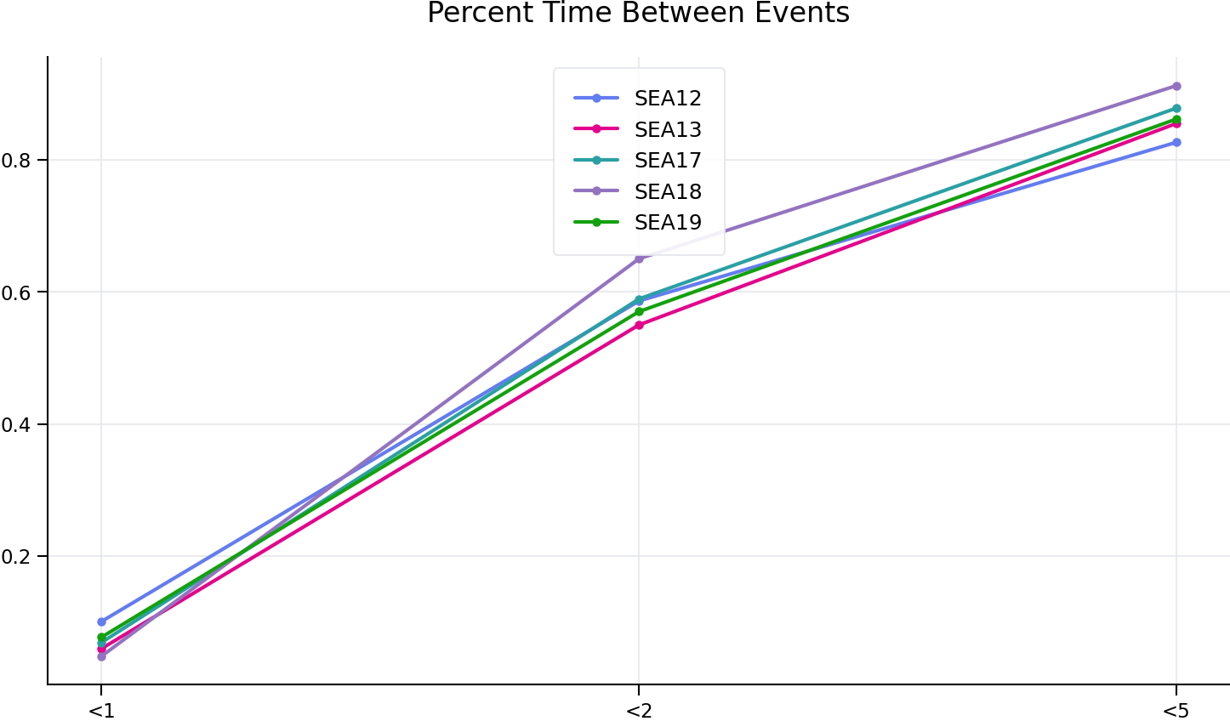
The majority of inter-event intervals across all monitors occur within short durations, confirming near-continuous exposure conditions. The southern monitors show higher concentrations of very short intervals, consistent with their position under primary departure tracks.

SEA12 Monitor Analysis (North Side)
SEA12 is located on the north side of SEA and primarily captures events on Runway 34R and mixed north-flow operations. During the study period, SEA12 recorded an average of approximately 204 noise events per day, with a median inter-event gap of 1.4 minutes. Approximately 58.6% of all intervals fell below 2 minutes. Extended quiet periods exceeding 10 minutes occurred 9.5% of the time—the highest rate of any monitor, but still representing only one extended respite opportunity roughly every 10 intervals. Nighttime events (22:00–07:00) averaged approximately 48 per night.

Figure 2 – SEA12 Hourly Event Distribution
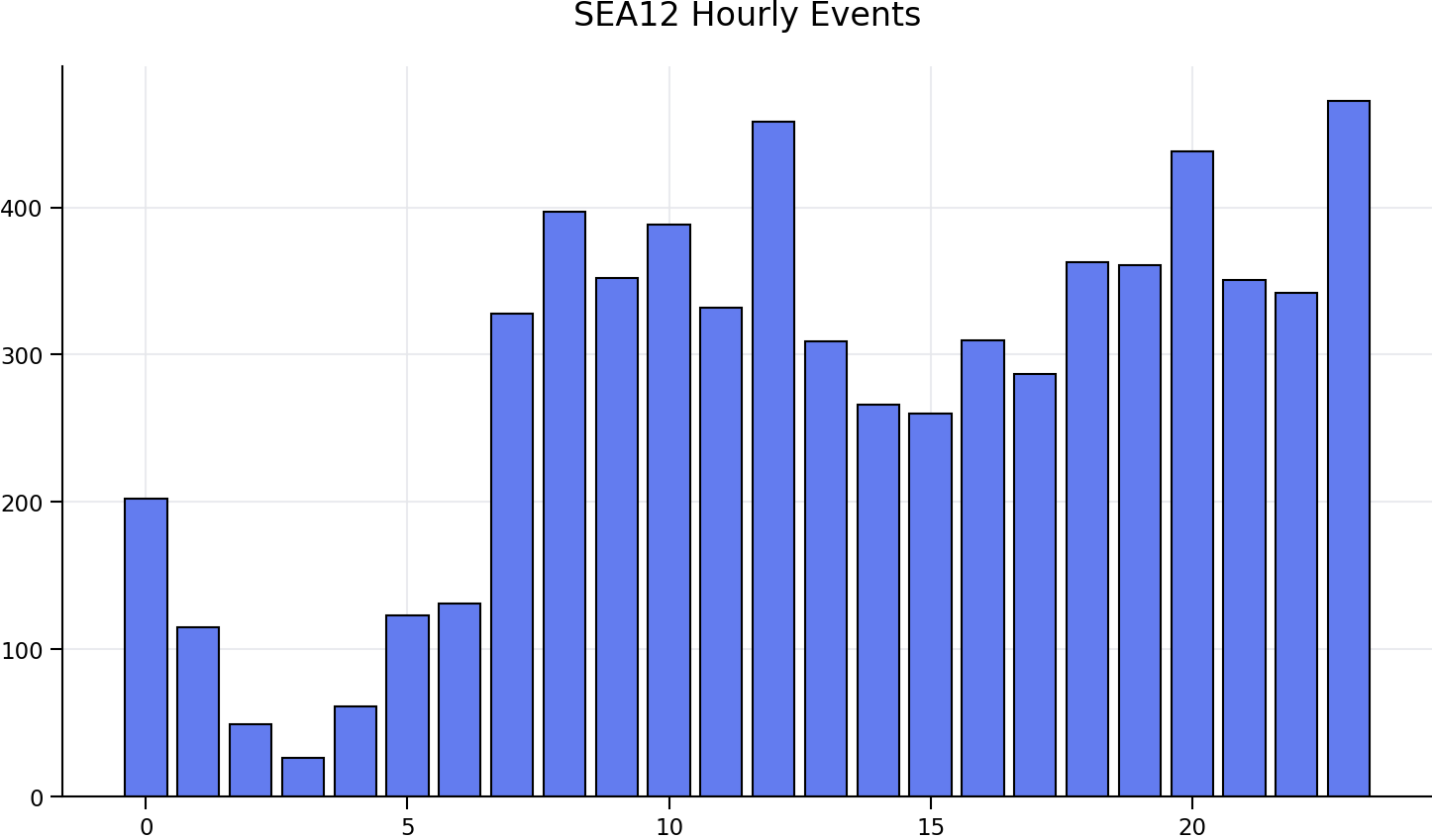
Hourly distribution shows temporal clustering of operations with peak periods in morning and evening hours corresponding to scheduled departure banks.

Figure 3 – SEA12 Inter-Event Respite Distribution
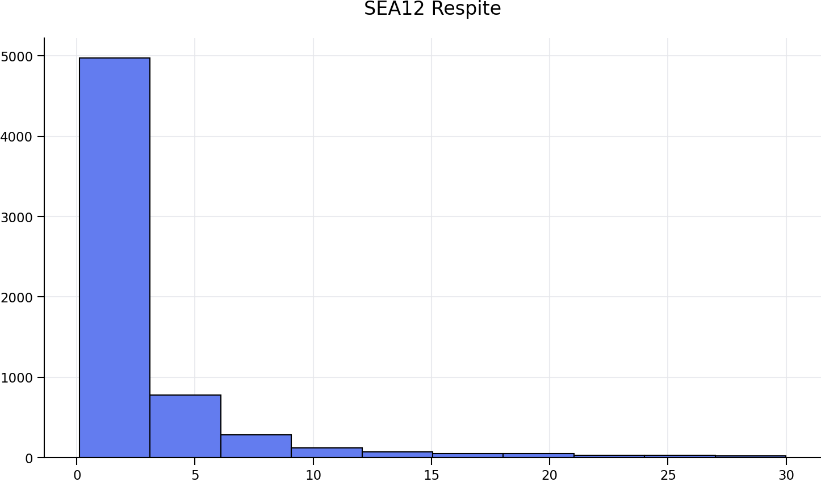
Respite distribution confirms that the majority of gaps between events are under 2 minutes, with limited recovery time available between noise exposures.

Figure 4 – SEA12 Nighttime Event Distribution (22:00–07:00)
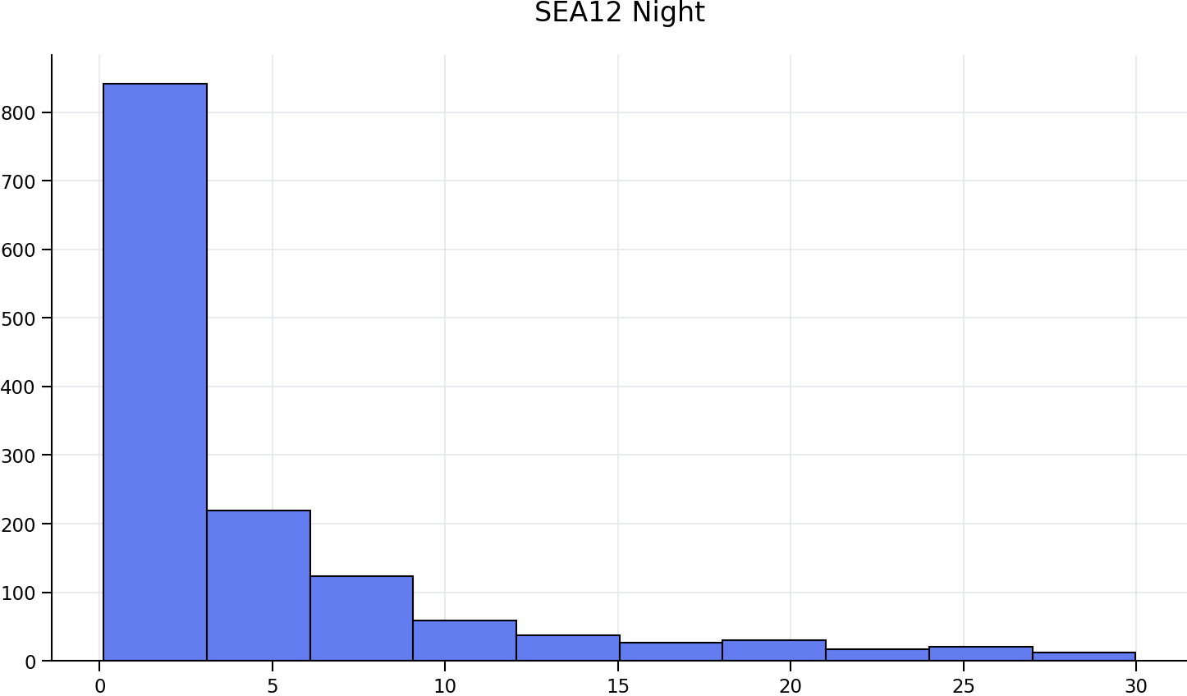
Approximately 48 nighttime events per night at SEA12, with persistent exposure across all nighttime hours. The WHO Lnight threshold of 40 dB is routinely exceeded.

SEA13 Monitor Analysis (South Side – Arrival Corridor)
SEA13 is located on the south side of SEA and primarily records events from Runway 16R arrivals and some Runway 34R departure activity. During the study period, SEA13 recorded an average of approximately 390 noise events per day, with a median inter-event gap of 1.8 minutes—the longest median gap of any of the five monitors, reflecting its position primarily under the arrival stream rather than the higher-density departure corridor. Approximately 55.0% of intervals fell below 2 minutes; 85.5% below 5 minutes. Extended quiet periods exceeding 10 minutes occurred 4.8% of the time. Nighttime events averaged approximately 59 per night.

Figure 5 – SEA13 Hourly Event Distribution
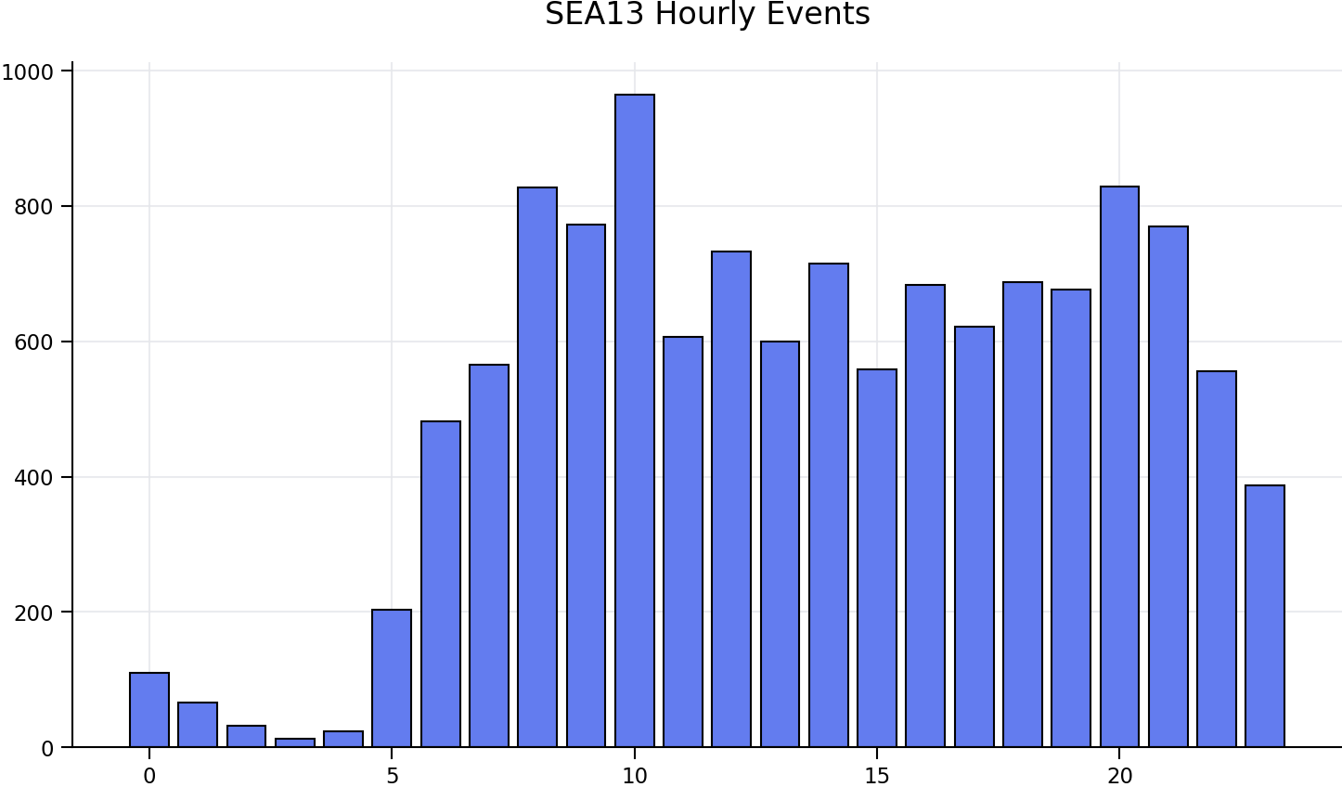

Figure 6 – SEA13 Inter-Event Respite Distribution
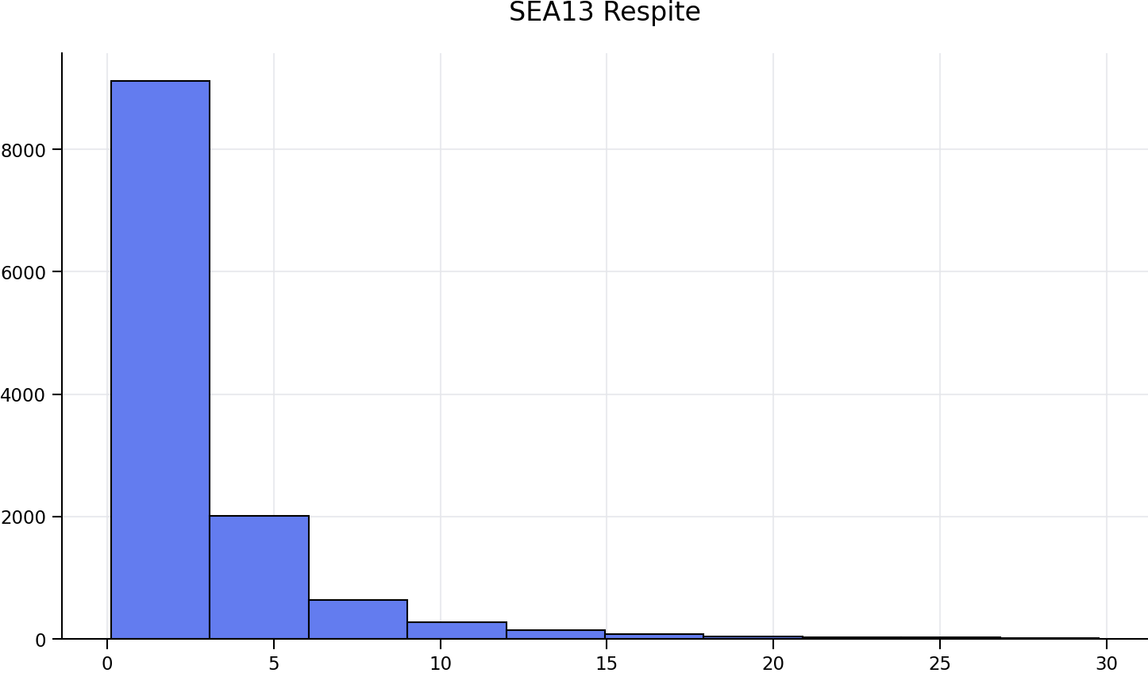

Figure 7 – SEA13 Nighttime Event Distribution (22:00–07:00)
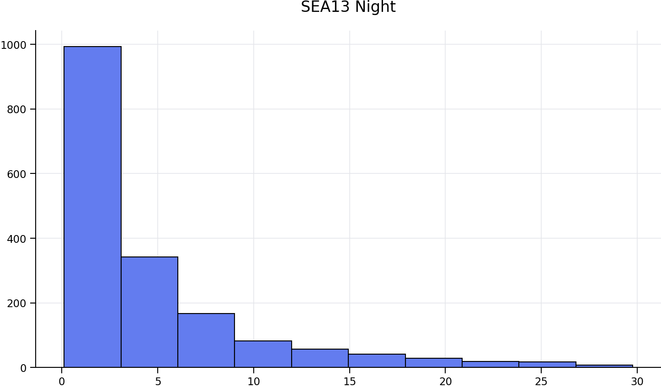

SEA17 Monitor Analysis (South Side – Departure Corridor)
SEA17 primarily records events from Runway 16L departures and some Runway 34L arrivals. During the study period, SEA17 recorded an average of approximately 414 noise events per day, with a median inter-event gap of 1.6 minutes. Approximately 58.9% of intervals fell below 2 minutes; 87.8% below 5 minutes. Extended quiet periods exceeding 10 minutes occurred only 3.7% of the time. Nighttime events averaged approximately 57 per night.

Figure 8 – SEA17 Hourly Event Distribution
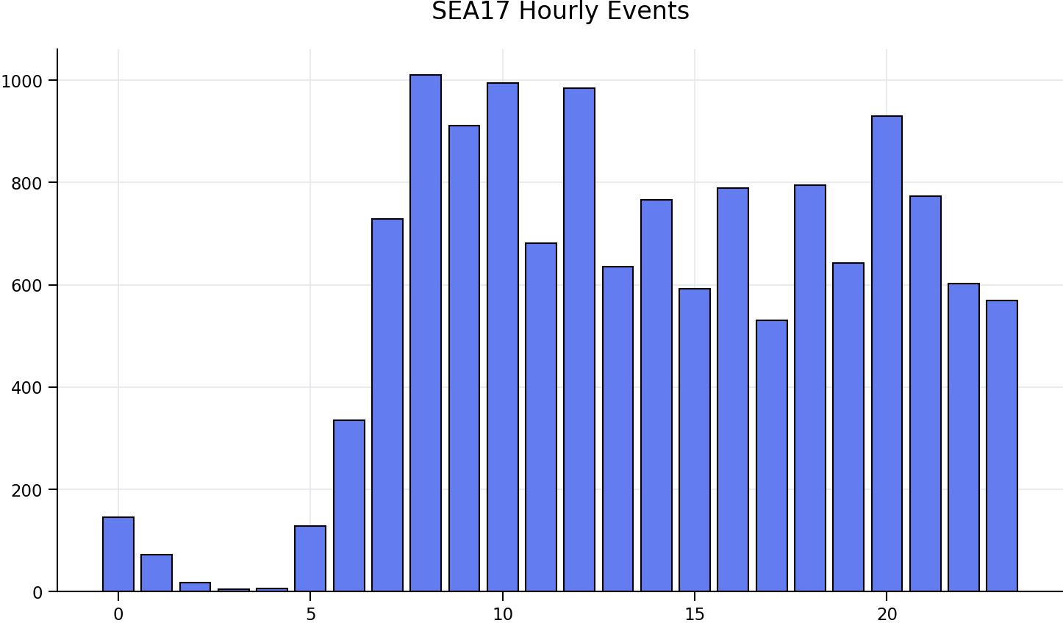

Figure 9 – SEA17 Inter-Event Respite Distribution
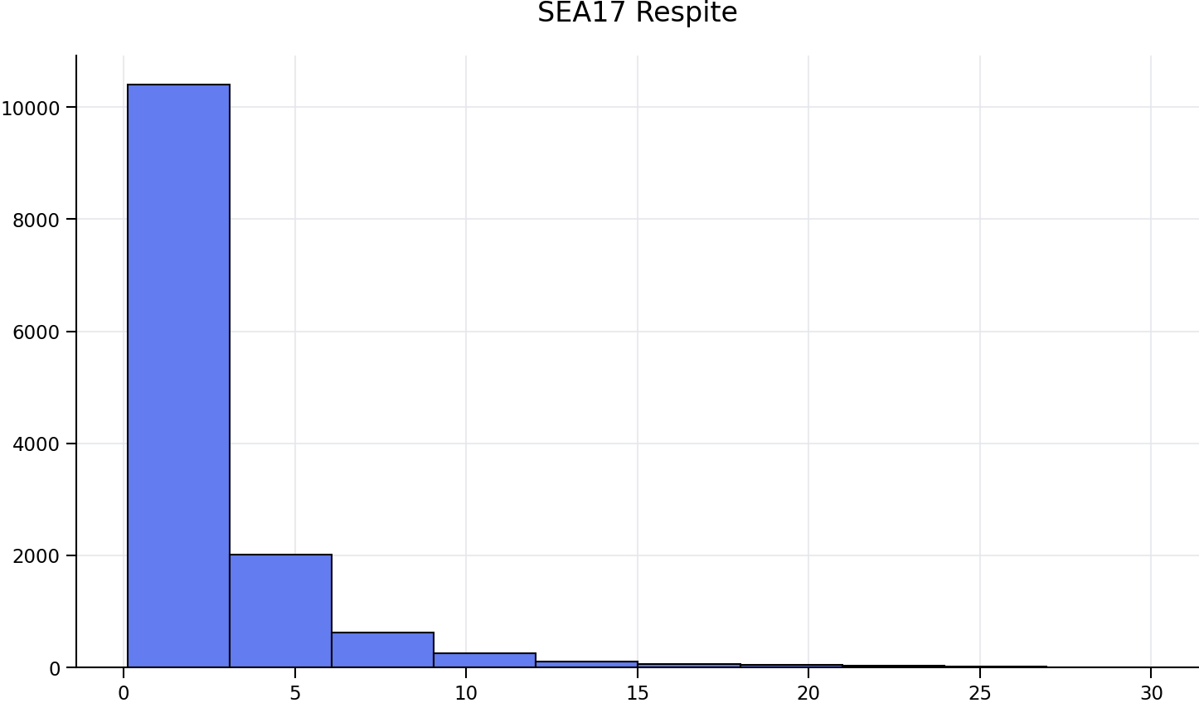

Figure 10 – SEA17 Nighttime Event Distribution (22:00–07:00)
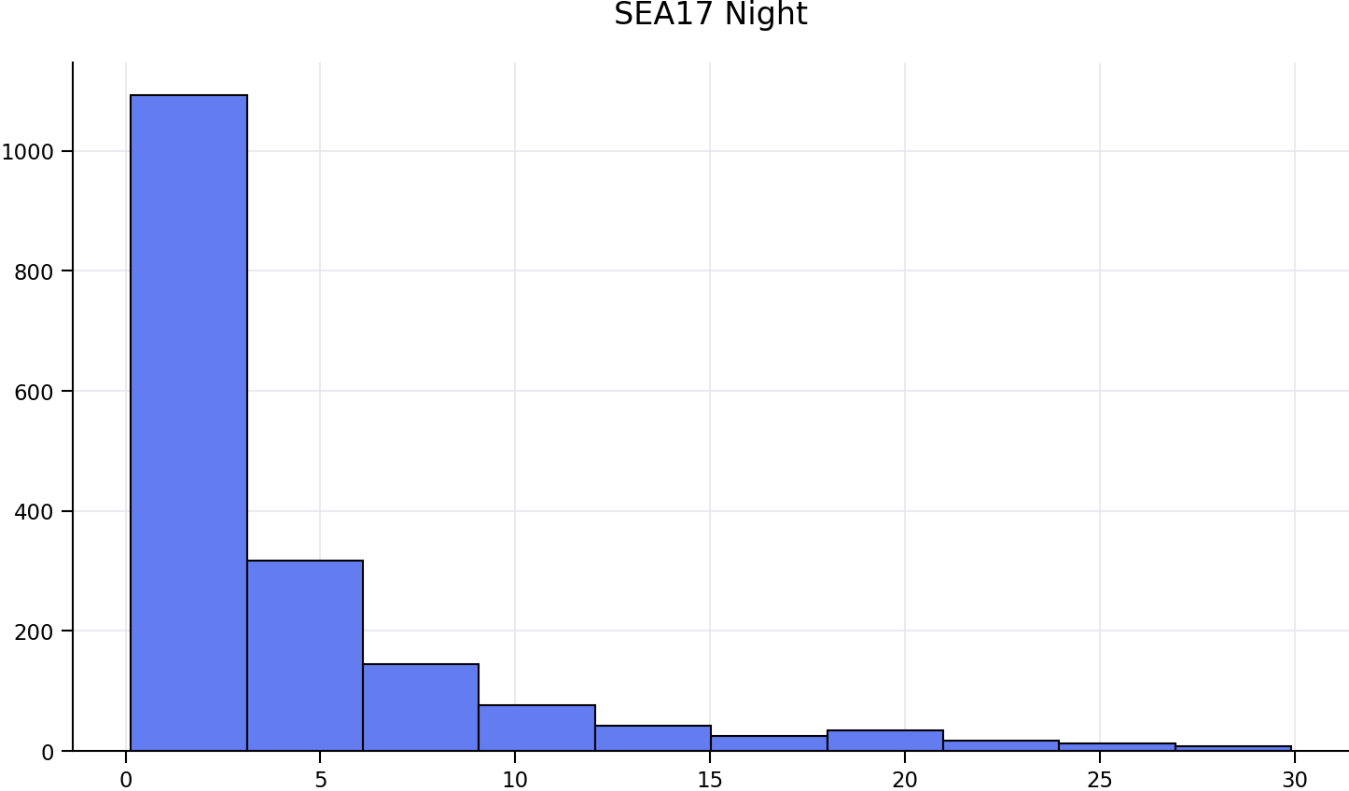

SEA18 Monitor Analysis (South Side – Highest Density Monitor)
SEA18 records the highest noise event density of any monitor in the study. It primarily captures Runway 16L departures and Runway 34L arrivals. During the study period, SEA18 recorded an average of approximately 529 noise events per day—the highest of all five monitors. The median inter-event gap was 1.5 minutes. Approximately 65.0% of all intervals fell below 2 minutes and 91.2% fell below 5 minutes. Extended quiet periods exceeding 10 minutes occurred only 2.8% of the time, meaning at any randomly selected moment during operating hours, the probability of having 10 minutes of quiet is less than 3 in 100. Nighttime events averaged approximately 89 per night, also the highest of any monitor and a level associated with measurable cardiovascular effects in the peer-reviewed literature.

Figure 11 – SEA18 Hourly Event Distribution
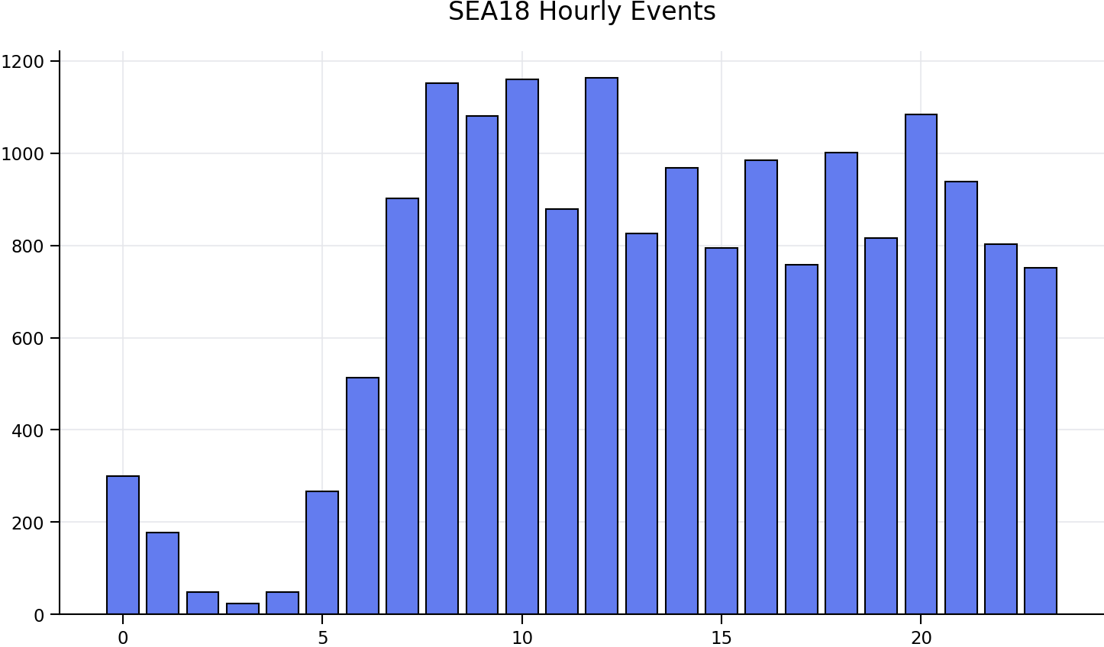

Figure 12 – SEA18 Inter-Event Respite Distribution
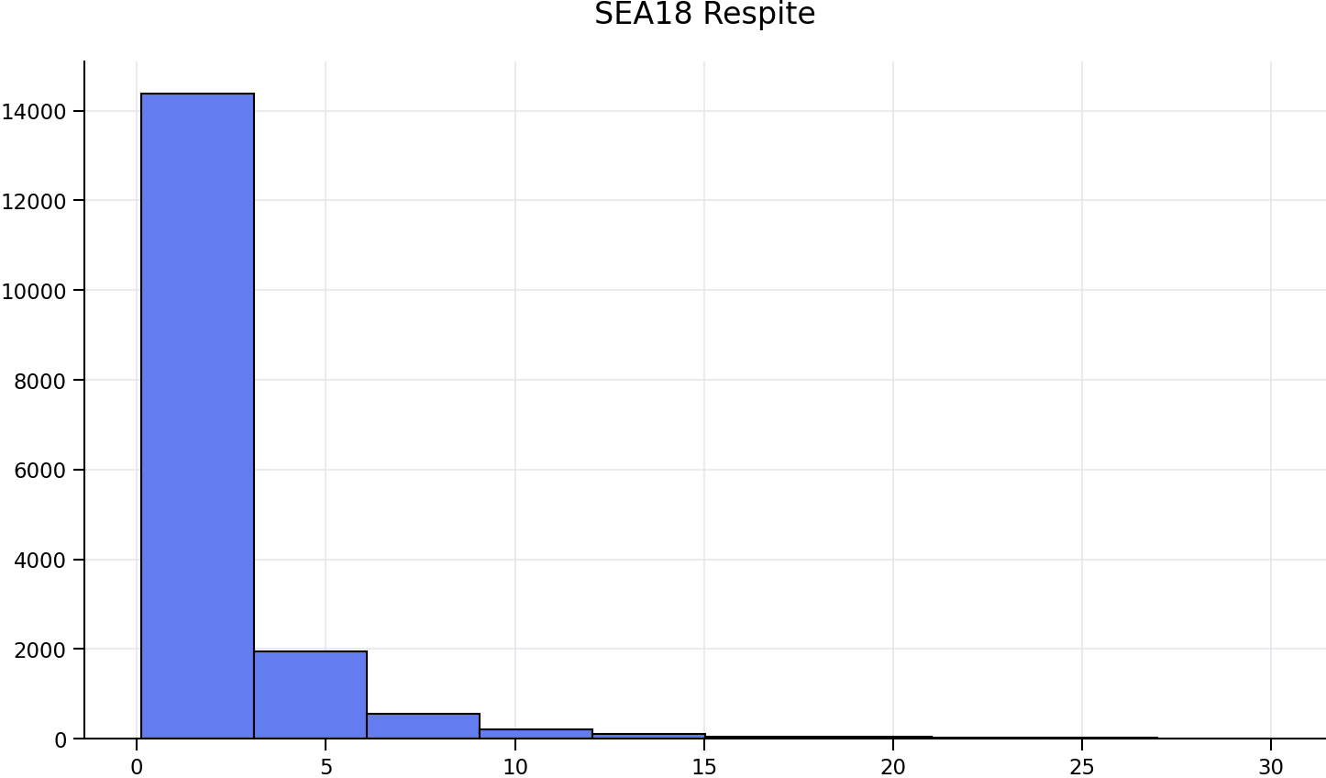

Figure 13 – SEA18 Nighttime Event Distribution (22:00–07:00)
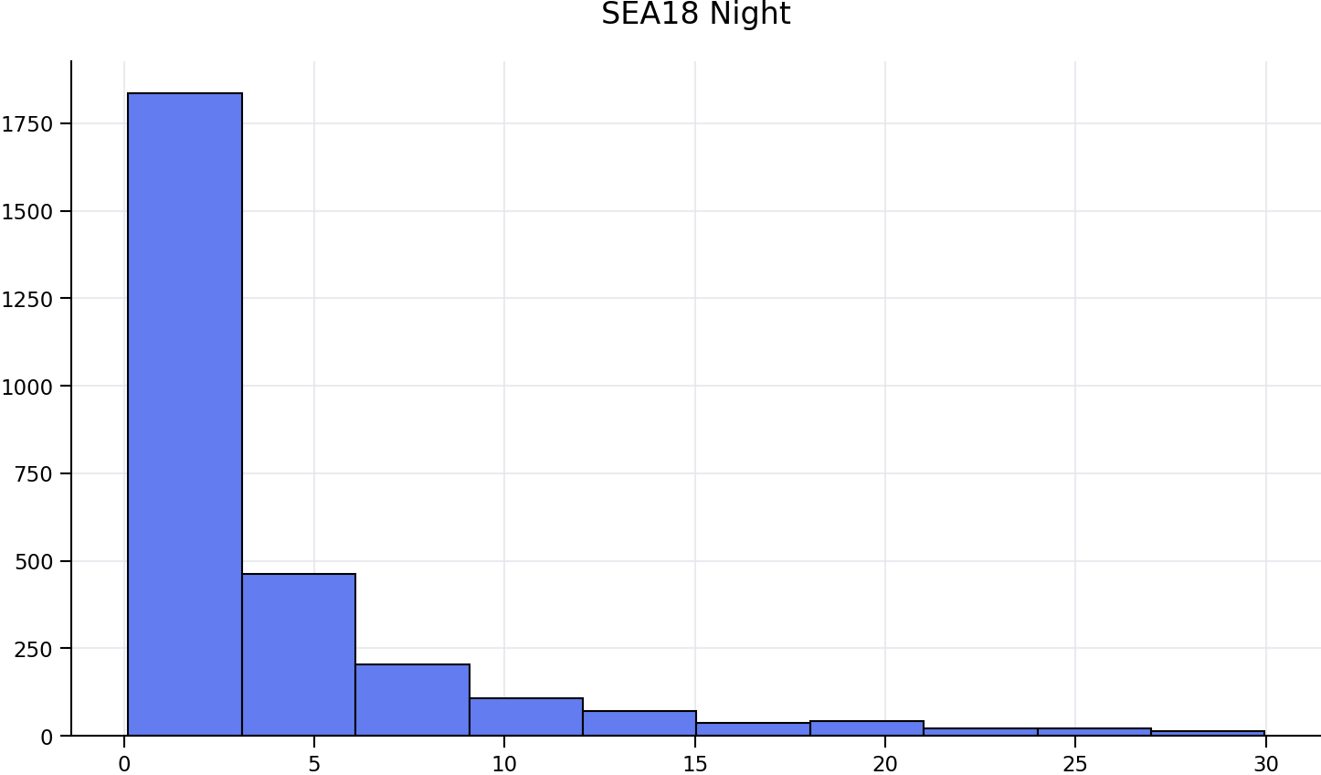

SEA19 Monitor Analysis (South Side – Departure Corridor)
SEA19 primarily records Runway 16L departure activity on the south side. During the study period, SEA19 recorded an average of approximately 332 noise events per day, with a median inter-event gap of 1.5 minutes. Approximately 57.0% of intervals fell below 2 minutes; 86.2% below 5 minutes. Extended quiet periods exceeding 10 minutes occurred 5.8% of the time. Nighttime events averaged approximately 55 per night.

Figure 14 – SEA19 Hourly Event Distribution
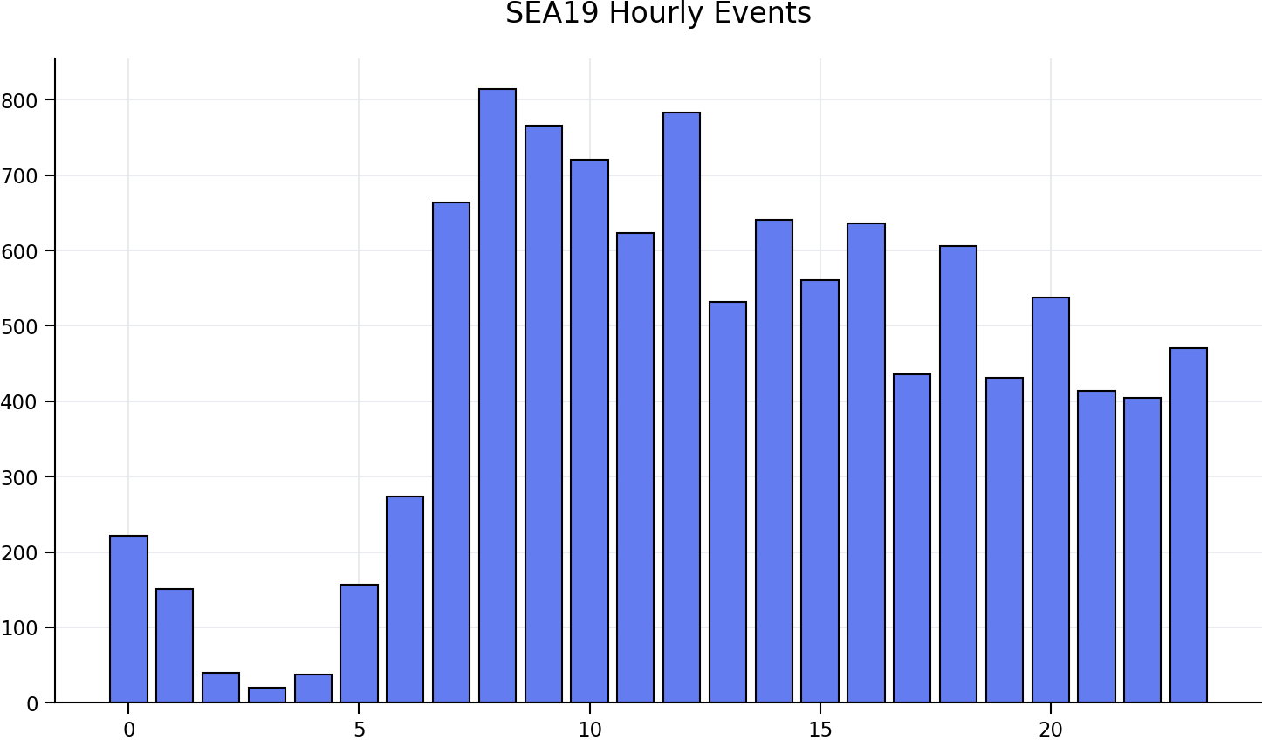

Figure 15 – SEA19 Inter-Event Respite Distribution
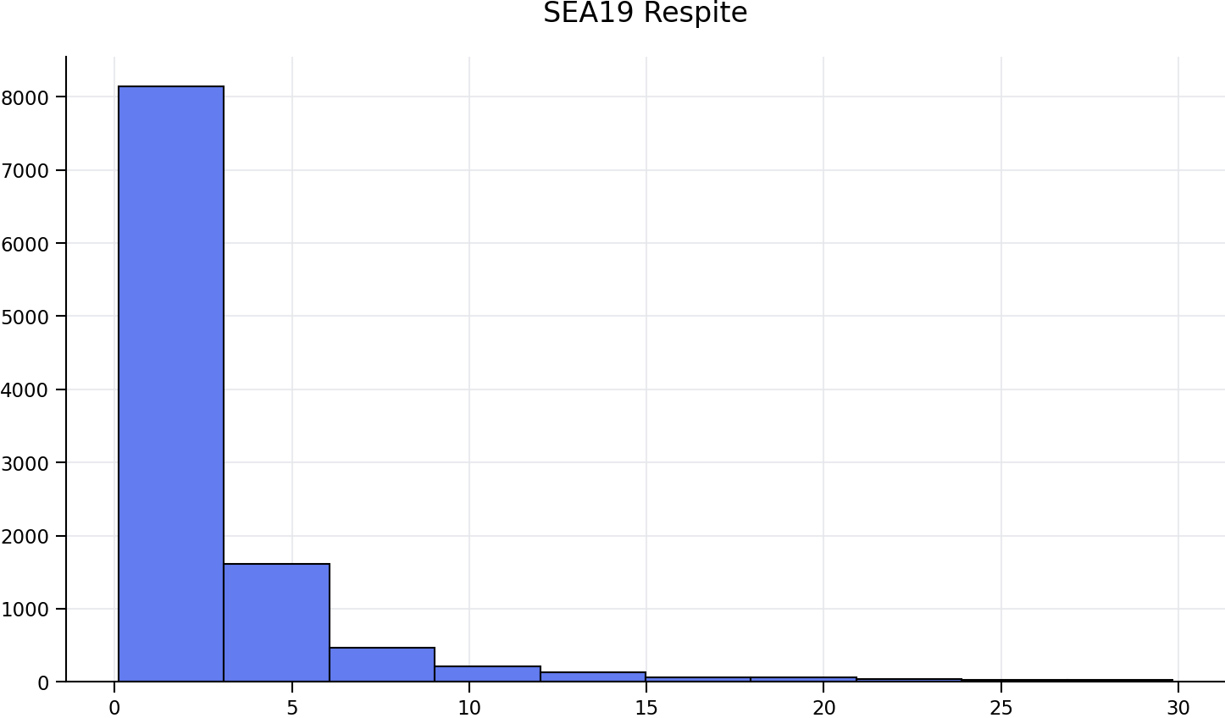

Figure 16 – SEA19 Nighttime Event Distribution (22:00–07:00)
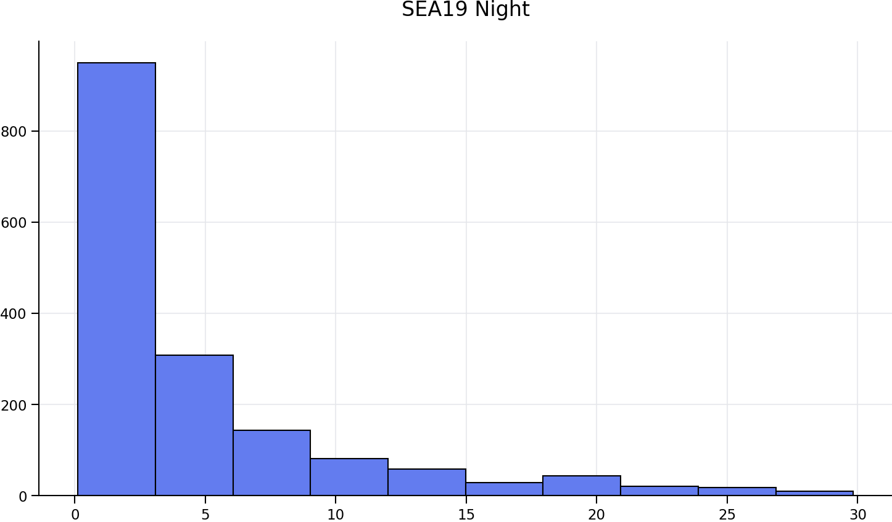

2032 Noise Exposure Projections: DEIS Growth Rates Applied to Measured Baselines
As described in Section 4, the SAMP DEIS projects a 25.3% increase in total airport operations under the constrained 2032 scenario and a 35.3% increase under the unconstrained scenario (DEIS Appendix A, base year 2022). These percentage growth rates are applied below to the directly measured per-monitor event baselines established in Section 5. The two data sources remain methodologically separate: the DEIS numbers establish the growth rate; the monitor records establish the baseline. No claim is made that the monitor dataset reproduces the total airport operations count.

Projected Daily Noise Events by Monitor
Table 1 presents the measured 2026 baseline event counts at each monitor alongside projections derived from the DEIS growth rates. The constrained scenario adds between 49 and 134 events per day depending on monitor location; the unconstrained scenario adds between 69 and 187.
Table 1. Daily Noise Events by Monitor: Measured 2026 Baseline and DEIS 2032 Projections
Monitor | Side | Measured 2026 (events/day) | 2032 Constrained +25.3% (events/day) | 2032 Unconstrained +35.3% (events/day) | Increase (Constr / Unconstr)
SEA12 | North | ~204 | ~256 | ~276 | +52 / +72
SEA13 | South | ~390 | ~489 | ~528 | +99 / +138
SEA17 | South | ~414 | ~519 | ~560 | +105 / +146
SEA18 | South | ~529 | ~663 | ~716 | +134 / +187
SEA19 | South | ~332 | ~416 | ~449 | +84 / +117
Growth rates (+25.3% constrained, +35.3% unconstrained) sourced from SAMP DEIS Appendix A (base year 2022, ~368,000 ops). Baselines are directly measured monitor event counts, March 12–April 9, 2026. Monitor event counts are community noise exposure records, not total airport operation counts. SEA18 in bold as highest-density monitor.

Projected Nighttime Exposure by Monitor
Table 2 presents the measured nighttime event baselines (22:00–07:00) alongside 2032 projections using the same DEIS growth rates. SEA18 currently averages approximately 89 nighttime events per night—the highest of any monitor and a level associated in peer-reviewed literature with measurable cardiovascular and sleep disruption effects. The constrained 2032 scenario projects approximately 112 nighttime events per night at SEA18; the unconstrained scenario projects approximately 120.
Table 2. Nighttime Noise Events by Monitor (22:00–07:00): Measured 2026 Baseline and DEIS 2032 Projections
Monitor | Measured 2026 (events/night) | 2032 Constrained (events/night) | 2032 Unconstrained (events/night)
SEA12 | ~48 | ~60 | ~65
SEA13 | ~59 | ~74 | ~80
SEA17 | ~57 | ~71 | ~77
SEA18 | ~89 | ~112 | ~120
SEA19 | ~55 | ~69 | ~74

Projected Compression of Inter-Event Respite
Increased operations necessarily compress the time between noise events. At SEA18, where the current measured median inter-event gap is already only 1.5 minutes, a proportional 25.3% increase in operations would reduce that median toward approximately 1.2 minutes; the unconstrained 35.3% increase would compress it further toward approximately 1.1 minutes. These estimates carry inherent uncertainty, but the structural conclusion is robust: any material increase in operations narrows an already critically short respite window.
Currently, extended quiet periods exceeding 10 minutes at SEA18 occur only 2.8% of the time. Under the 2032 constrained scenario, this already-rare respite window would be further compressed. Peer-reviewed literature (Basner et al. 2023, WHO 2018) identifies 3–5 minutes as a minimum recovery interval for meaningful physiological respite from noise-induced stress activation. The current median gap of 1.5 minutes already falls well below this threshold; the 2032 projections would deepen that deficit at all five community monitor locations.

SEPA Significance and Requested Supplemental Analysis
WAC 197-11-794 prohibits agencies from establishing automatic numerical thresholds for significance determinations. The DEIS implicitly treats the DNL 65 dB contour as such a threshold, analyzing noise impacts only within that boundary and treating everything outside it as non-significant by default. This approach does not satisfy WAC 197-11-330’s requirement for a reasonably thorough discussion of probable significant adverse environmental impacts, because it excludes from analysis the dimensions of noise exposure—event frequency, respite, and nighttime event count—that the peer-reviewed literature most directly associates with health outcomes.
The DEIS’s own Appendix A projects a 25.3% increase in airport operations under the constrained 2032 scenario. Applied to the directly measured baselines established in this submission, that growth rate produces material increases in daily and nighttime noise events at every community monitor location. Those increases are not captured, analyzed, or disclosed anywhere in the DEIS’s significance analysis.
This submission therefore requests that the Port of Seattle supplement the DEIS to include: (1) a current baseline characterization of daily and nighttime event counts, inter-event respite intervals, and temporal clustering at each operational noise monitor, using the Port’s own SEL dataset; (2) a 2032 constrained and unconstrained projection of those same event-based metrics using the DEIS’s own operational forecasts; and (3) a substantive significance determination—not defaulting to the DNL 65 dB threshold—addressing whether the projected increase in event frequency and loss of respite constitutes a probable significant adverse environmental impact under WAC 197-11-330 and WAC 197-11-794.

Why the 2032 Projections Are Conservative: Parallel Operations and Non-Linear Exposure Growth
The proportional scaling method used in Section 6—applying the DEIS’s +25.3% and +35.3% growth rates to the current measured event baselines—is methodologically defensible and conservative in the precise technical sense: it is more likely to understate future community noise exposure than to overstate it. Three distinct mechanisms, each grounded in the measured data and in the stated design intent of the SAMP Near-Term Projects, explain why. The DEIS addresses none of them.

Mechanism 1: Proportional Scaling Assumes Today’s Sequential Operation Mix Persists
Proportional scaling is valid only if the ratio of parallel to sequential runway operations remains constant between the baseline and future periods. The SAMP NTPs are explicitly designed to change that ratio. The Port of Seattle has stated that the NTPs will “add as much new flight capacity as adding a new runway” without constructing one. The mechanism for that capacity gain is increased simultaneous multi-runway utilization—more operations conducted in parallel rather than in sequence. Taxiway geometry improvements, high-speed turnoff additions, and airfield efficiency projects included in the NTPs are specifically intended to reduce runway occupancy time and enable higher rates of simultaneous departure and arrival activity across the runway system.
When more operations occur in parallel rather than in sequence, the increase in community noise event rate is not proportional to the increase in total operations—it is amplified, because a second simultaneous departure stream produces events at a monitor that were previously temporally separated. Proportional scaling from a predominantly sequential baseline therefore systematically understates the event rate increase at community locations under a future regime of higher parallel utilization.

Mechanism 2: Runway 16C Is Currently Underutilized and Sits Under the Same Monitor Paths
The measured data reveals a particularly important structural feature of the current baseline: Runway 16C (the center runway) currently accounts for only 1.7% of all events recorded at SEA18 and a similar fraction across the study monitors. This is not because 16C generates quieter operations—it is because 16C is operationally underutilized under the current airfield configuration, which limits the frequency of simultaneous 16L and 16C departures due to taxiway geometry constraints that the SAMP NTPs are specifically designed to remove.
The SEA17 and SEA18 monitors sit under both the Runway 16L and Runway 16C departure flight paths. In the current measured dataset, 3-minute windows containing events from both 16L and 16C departures occur at SEA17 approximately 1.74% of the time and at SEA18 approximately 1.57% of the time—already rare but measurable instances of parallel operation. Post-NTP, if taxiway improvements enable routine simultaneous 16L and 16C departure banks during peak hours, the effect at SEA17 and SEA18 is not a proportional increase in events from a single departure stream: it is the activation of a second departure stream on a path those monitors already sit under. The event rate increase during those peak windows would be non-linear—potentially approaching double the current rate during the periods of highest community concern.
This is precisely the capacity mechanism the SAMP NTPs are designed to exploit, and it is precisely the impact pathway the DEIS does not analyze. The DEIS projects more total operations without disclosing that the additional operational capacity is achieved through more simultaneous runway use at the monitors most heavily affected by existing noise exposure.

Mechanism 3: Noise Envelopes Overlap—Sequential Events Already Merge Into Continuous Sound
A single aircraft departure produces an audible noise envelope of approximately 20 to 40 seconds at the distances represented by the community monitors analyzed in this submission. When two consecutive events are separated by less than that duration, the noise from the first aircraft has not ended before the noise from the second begins—the community experiences not two discrete events with a gap between them, but a single prolonged noise exposure. The analysis in this submission counts such occurrences as two events and measures the interval between them, but the physiological reality is unbroken noise.
The measured data at SEA18 documents this phenomenon in the current baseline: 117 events in the 33-day study period (0.7% of all events) occurred within 30 seconds of the preceding event, and 841 events (4.8%) occurred within 60 seconds. The minimum recorded gap between consecutive events at SEA18 was 7 seconds. At 90-second spacing—which encompasses approximately 49.7% of all events at SEA18—the noise envelopes of consecutive events are, at minimum, partially overlapping.
Proportional scaling increases the count of discrete events while implicitly maintaining the framework of events separated by gaps. Under higher parallel utilization, the proportion of events with overlapping noise envelopes increases disproportionately, because parallel operations are by definition time-compressed relative to sequential ones. The community impact is therefore worse than the projected event count implies: not only are there more events, but a higher fraction of those events produce no perceptible gap at all.

The Only Meaningful Respite Window Is the Early Pre-Dawn Hours—and It Is Directly Threatened
Analysis of the hourly distribution of inter-event gaps at SEA18 reveals that genuine respite—defined as median gaps materially exceeding the 3–5 minute physiological recovery threshold—occurs during only a narrow pre-dawn window. During all hours from 07:00 through 23:00, the median gap at SEA18 ranges from 1.3 to 1.7 minutes: there is no waking hour in which the community currently experiences meaningful recovery between events. The only hours with median gaps above the 3-minute threshold are 00:00 (3.6 min), 01:00 (6.6 min), 02:00 (16.2 min), 03:00 (49.2 min), and 04:00 (24.2 min). By 05:00, the median gap has fallen to 4.4 minutes as early morning departures begin, and by 06:00 it has collapsed to 2.4 minutes. By 07:00 it is 1.4 minutes—indistinguishable from the all-day average.
The physiological significance of this pattern cannot be overstated. The 02:00–04:00 window represents the only period in the 24-hour cycle during which residents near SEA18 have any realistic prospect of sustained sleep without noise interruption. That window is directly defined by the rate of early morning departures. Any increase in operations that advances or intensifies the early morning departure bank—including the kind of efficiency-driven early push that increased runway throughput capacity enables—directly attacks the one recovery window that currently exists.
The DEIS does not analyze the hourly distribution of operations under the 2032 scenarios. It does not disclose whether the early morning departure bank would expand. It does not evaluate the health significance of the pre-dawn respite window or assess whether projected growth would narrow or eliminate it. These are not peripheral concerns—they go to the core of whether the DEIS provides the reasonably thorough cumulative impact analysis that SEPA requires.

What the DEIS Is Required to Address
The three mechanisms described above each constitute an independent basis on which the proportional projections in this submission understate future community noise exposure. Together, they establish that the DEIS’s noise analysis is conservative in the wrong direction—it omits the pathways through which the SAMP NTPs would produce the most significant community impact. Under WAC 197-11-330 and WAC 197-11-794, the Port of Seattle is required to analyze probable significant adverse environmental impacts and may not rely on automatic numerical thresholds to avoid doing so. The following specific analytical gaps must be addressed in the Final EIS:
- Disclosure of the projected change in parallel versus sequential runway utilization under the 2032 constrained and unconstrained scenarios, including the projected frequency of simultaneous Runway 16L and Runway 16C departure operations post-NTP, and the community noise event impact at monitors located under both departure paths.
- Analysis of the hourly distribution of operations under 2032 scenarios, specifically including the projected timing and intensity of early morning departure banks and their effect on the pre-dawn respite window (approximately 02:00–05:00) that currently provides the only sustained recovery opportunity at heavily impacted monitor locations.
- Evaluation of noise envelope overlap under projected parallel operation scenarios, and an assessment of whether increased simultaneity would convert currently-discrete events with measurable gaps into periods of effectively continuous noise exposure at community monitor locations.
- A significance determination under WAC 197-11-330 that addresses whether these non-linear, parallel-operation-driven noise exposure increases constitute probable significant adverse environmental impacts that cannot be dismissed by reference to the DNL 65 dB contour boundary.

Conclusion
Aircraft noise exposure at the community monitor locations studied is characterized by frequent, closely spaced events with limited inter-event recovery time, resulting in near-continuous exposure conditions that are directly associated with documented adverse health outcomes. These conditions exist under current operations and would worsen materially under the DEIS’s own projected growth scenarios.
The evidence presented in this submission rests on two independently valid foundations: directly measured noise events at community locations, which require no modeling assumptions; and the DEIS’s own operational forecasts, which establish the growth rates applied to those baselines. Neither foundation is in dispute. What is absent from the DEIS is any analysis connecting them—any evaluation of how the projected increase in operations translates into increased noise event frequency, reduced respite, or worsened nighttime exposure at the community level. Moreover, as demonstrated in Section 7, the proportional projections presented here are themselves conservative: the SAMP NTPs are designed to increase parallel runway utilization in ways that would amplify community noise exposure non-linearly, threaten the only meaningful pre-dawn respite window that currently exists, and activate a second departure stream at monitors already recording near-continuous exposure from a single stream. The DEIS addresses none of these mechanisms.
Because the SEPA DEIS relies exclusively on DNL averaging, it cannot capture or disclose these temporal dimensions of cumulative exposure. SEPA’s requirements for reasonably thorough environmental review and prohibition on automatic numerical significance thresholds require that this gap be addressed in the Final EIS.

