FORMAL COMMENT by Jeffrey Bogen, Des Moines Resident, 5/28/2026
SAMP EIS - Environmental Impact Statement
SEA Aircraft Fleet Mix Seat Estimates Assumptions Not Accurate Today
________________________________________________________________________

The SAMP Aircraft Seat Estimates Assumption Looking Increasingly Questionable

Background
Alaska Airlines — The SAMP Was Right - But the Story Has Changed Today
The SAMP correctly noted Alaska lacked larger aircraft. But that analysis has materially shifted:
- In January 2026, Alaska announced its largest fleet order in the airline's history — 105 Boeing 737-10 aircraft and 5 new 787 widebody jets, with the firm future 787 fleet growing to 17 aircraft. The 737-10 is the longest-range, highest-capacity narrowbody in the 737 family, representing meaningful upgauging even within the narrowbody tier.
- Alaska is explicitly targeting at least 12 long-haul international destinations from Seattle with widebody aircraft by 2030, and has already launched daily nonstop service to Tokyo Narita — the beginning of what the airline calls "a new era of widebody international flying" from Seattle.
- Alaska describes its goal as transforming Seattle into the West Coast's premier global gateway, noting SEA is the closest connection point between the continental U.S. and Tokyo — 7% closer than San Francisco and 13% closer than Los Angeles.
This is a structural change in Alaska's fleet and strategic position at SEA — not a marginal adjustment.

Delta — Major Commitments at SEA
The SAMP acknowledged Delta had capacity to upgauge, but its subsequent actions at SEA have been aggressive:
- Delta has secured a long-term lease giving it priority access to 18 gates across Concourses A and B, plus launched a new Delta One Lounge and renovated Sky Club — a significant long-term infrastructure commitment to SEA.
- Delta is adding Rome and Barcelona service from Seattle using Airbus A330-900 widebodies, bringing its transatlantic portfolio at SEA to five destinations alongside existing Amsterdam, Paris, and London Heathrow service.
- Delta's broader "pivot to the Pacific" strategy includes year-round flights between Seattle and Taipei — a direct widebody addition to the SEA international portfolio.
- Delta also placed a major order for up to 60 Boeing 787-10 Dreamliners in early 2026 to support long-haul international growth and fleet modernization. More widebodies in the fleet generally means more opportunities to deploy them on high-yield routes like those from SEA.

New SEA Baseline Seat Capacity Estimate
Using this updated SEA Fleet Mix status, a new seat capacity estimate can be made to the SAMP which is important as it materially changes the overall aircraft noise around the airport.
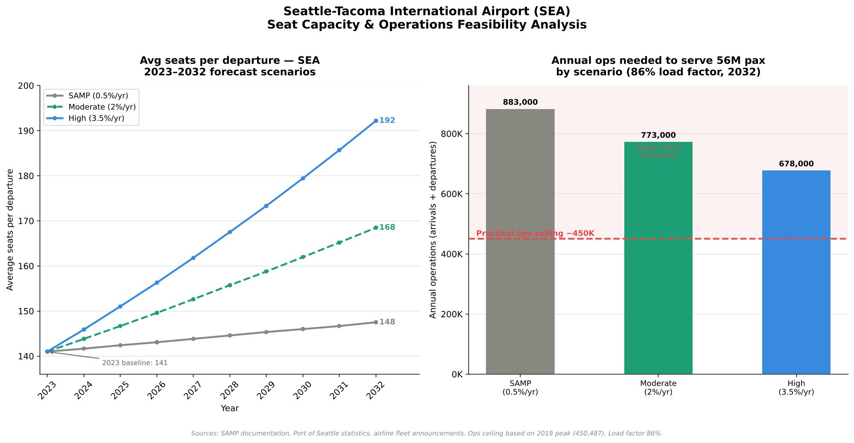
SAMP Passengers Estimates vs. Revised Operations Estimate Table
SAMP Estimate (0.5%) Ops constrained  56M pass. ÷ 148 seats × 2 (arr+dep) ≈ 757K ops needed — far exceeds ceiling. SAMP must assume very high load factors to close the gap. Internally inconsistent. | Moderate (2%) tighter fit  Higher seats per departure means fewer operations needed per passenger. More headroom under the ops ceiling. 56M pass. more plausible without breaching ~450K ops. | High (3.5%) best ops fit  187 seats/dep means meaningfully fewer movements per passenger. Could accommodate 56M+ pax well within the ops ceiling — and supports even higher passenger targets.

Updated Aircraft Seat Capacity Findings
This analysis reveals a fundamental internal contradiction in the SAMP — and it actually makes the case for faster up-gauging aircraft fleet mix more compelling than any airline strategy argument alone.
The SAMP's 0.5% gets you from 141 to just 148 by 2032 — a gain of only 7 seats per departure over nine years. That's a remarkably modest change, essentially assuming SEA's fleet mix stays almost frozen.
The moderate scenario at 2% reaches 168 — a 27-seat gain that's broadly consistent with what you'd expect if Alaska's 787 hub grows to 10–12 widebody routes and the 737-10 gradually replaces older 737s domestically. That feels like the most defensible central estimate given what's already been announced.
The high scenario at 3.5% reaches 187 — which would imply SEA's average departure is starting to look more like a mid-sized widebody-weighted hub. That's ambitious but not implausible if Alaska fully executes its 12-route international target and Delta continues its Pacific pivot with larger A350s.
One important nuance: average seats per departure can be driven by two very different things — more widebodies on international routes (high seats, low frequency) or larger narrowbodies on domestic routes (moderate seat gains, high frequency). The 737-10 order alone, replacing older 737-800s across Alaska's domestic network, could contribute 15–20 additional seats per departure on those flights without a single new widebody. That makes even the moderate scenario feel fairly conservative.

The Math That Breaks SAMP's Own Assumptions
SEA logged 435,896 total operations in 2025 and handled 52.72 million passengers — meaning the airport is already operating at roughly 97% of its historical peak throughput while carrying passengers at 94% of the SAMP's 2032 target. That gap closes in roughly two to three years at current trend, not seven.
The pre-third-runway capacity ceiling was about 380,000 operations per year; the third runway expanded practical throughput, but the 2019 peak of 450,487 operations represents an effective practical ceiling given ATC constraints, runway stagger geometry, noise corridors, and Boeing Field interactions — all of which are structural, not fixable by SAMP projects.
Here's the critical math which SAMP underestimates: if you assume 56 million passengers by 2032, an 86% load factor (typical industry average), and only 148 seats per departure (the SAMP's 0.5% growth scenario), you need roughly 880,000 total operations — arrivals plus departures — to carry those passengers. That's nearly double the physical ceiling. Even accounting for connecting passengers reducing the per-operation passenger count, the numbers only work if you assume load factors well above 90% and meaningful upgauging simultaneously. The SAMP can't have both a conservative seat growth assumption and a 56 million passenger target — they're arithmetically incompatible at any realistic load factor. How SEATAC would get to 70 million passengers in the out years past 2032 seems exceedingly challenging without some major, as of yet undeveloped improvement scenario.
What Makes The 56 million Target Achievable
The SAMP near-term projects are specifically designed to accommodate 56 million passengers and meet forecasted demand to 2032, but the infrastructure investment — a second terminal with 19 new gates in roughly 575,000 square feet — addresses terminal throughput and gate capacity, not substantial runway operation increases. More gates enable larger aircraft to be handled more efficiently, which is an implicit endorsement of upgauging, but it is not a validation of the 0.5% assumption.
The conclusion is that the SAMP's passenger target and its seat growth assumption are pulling in opposite directions. The only way to serve 56 million passengers without busting the operations ceiling is faster upgauging — which means the moderate or high scenario isn't a stress case, it's a prerequisite for the plan's own goals to be internally consistent.
What does this really mean for aviation noise impacted communities: There is going to be a big push to accommodate larger planes to accommodate estimated passenger growth; this is not well elucidated in SAMP. Larger planes, even with only modest increases in overall airport capacity, will be noisier. While this may not violate any current FAA or EPA policy/regulation, the perceived low frequency noise coming from those larger aircraft will make our communities noisier each year, for years to come.
It is important to note that since FAA DNL 65 calculations heavily average and roll off low frequency noise component levels, these larger planes will never cause an official “significant impact” under current rules. But, in fact, it is an impact that is well recognized by many organizations throughout the world.
This should be included and highlighted in the SAMP, regardless of regulatory statutes, and fairly communicated to our SEATAC surrounding neighborhoods. The time for additional noise mitigation advocacy is now – and not simply wait for national noise/health regulations to catch up. The Port of Seattle can lead here - to advocate and protect the health and well being of aircraft noise impacted surrounding communities.

