FORMAL COMMENT by Jeffrey Bogen, Des Moines Resident, 5/28/2026
SAMP EIS - Environmental Impact Statement
Health Impacts Cumulative Effects Missing In SAMP EIS
________________________________________________________________________
Complete Cumulative Effects Exposure Near SEA – Missing in SAMP EIS
Cumulative Effects, SAMP EIS, Section 5.4 does not include the fundamental environmental analysis needed and expected in a professional EIS. Cumulative impacts need to analyzed not just int terms of additional action alternatives for each SEPA element but also include the associated cumulative effects for the entire SAMP. While many of the baseline and individual additive environmental data is included in the report, there is no cumulative effect reviewed for these additive environmental stress factors.
Communities near SEA face a layered pollution burden from aircraft ultrafine particles (UFPs), roadway traffic emissions, and other environmental stressors. Scientific evidence shows that aircraft-related UFPs are distinct, additive, and biologically active in different ways than roadway UFPs. This makes cumulative exposure — not aviation alone — the correct and scientifically supported framework for assessing health risk.
What Cumulative Effects should be in the SEPA EIS
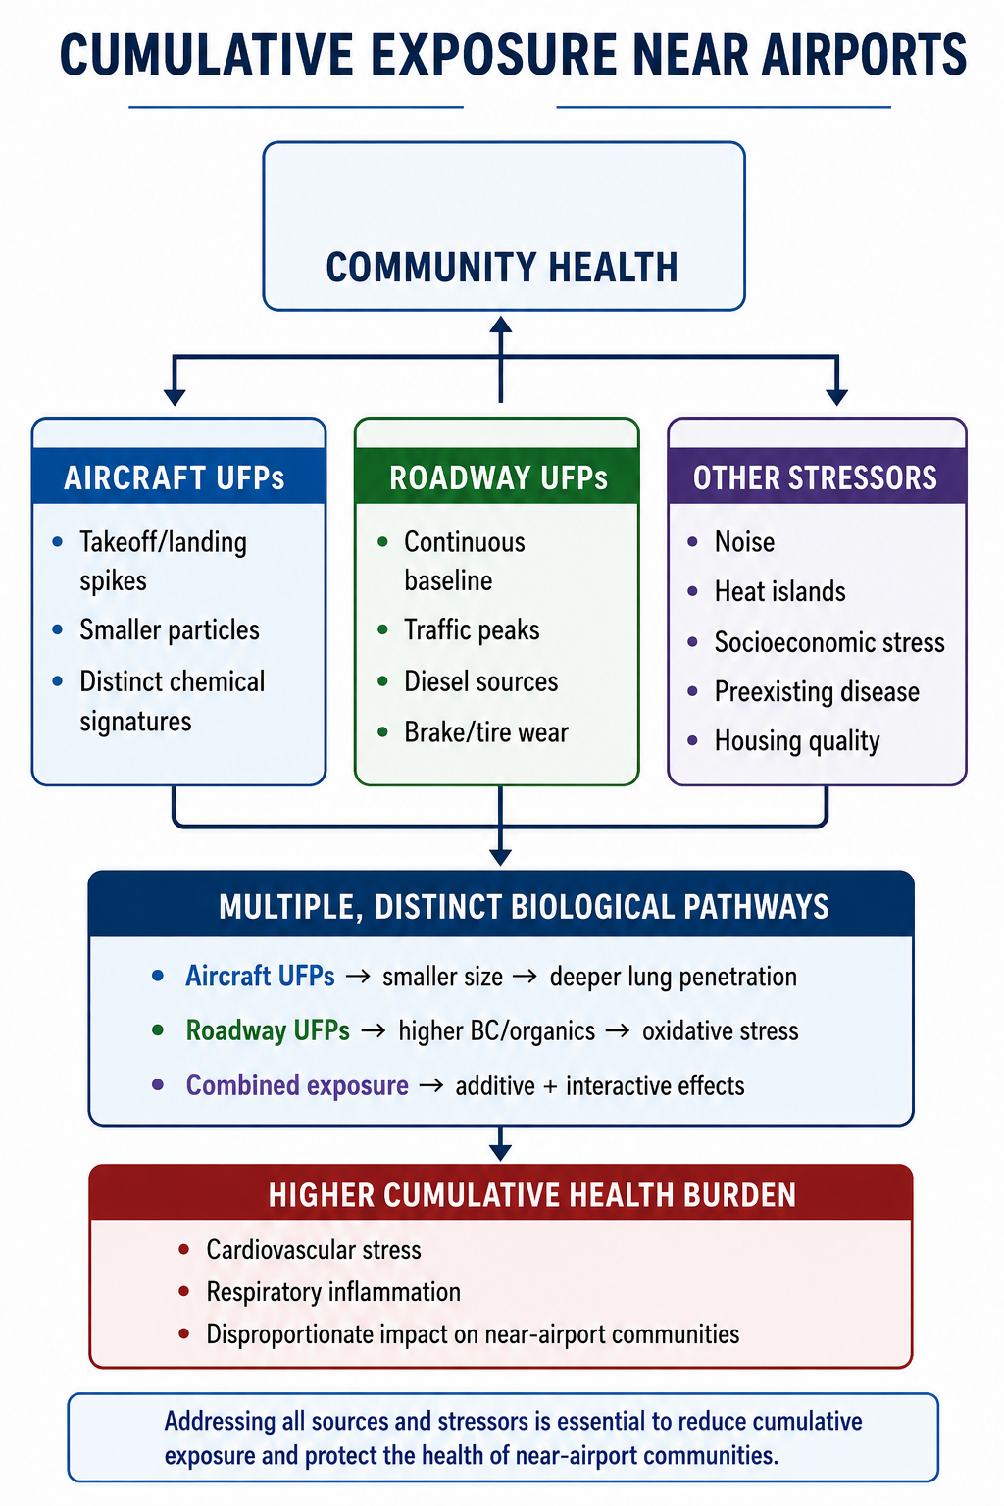

SEA SAMP EIS Cumulative Effects should consider the following science which is well documented in the 10 peer reviewed studies which are included at the end of this paper.
1. Aircraft Takeoffs and Landings Create Intense UFP Spikes
- Aircraft operations generate sharp, short-duration UFP plumes with particle sizes in the smallest, most biologically reactive modes.
- Monitoring studies around major U.S. airports show aircraft UFP signatures detectable up to ~10 miles downwind, far beyond the 1 km range historically assumed. This is specifically documented for SEA in: Austin E, Xiang J, Gould T, et al. “Distinct Ultrafine Particle Profiles Associated with Aircraft and Roadway Traffic.” Environmental Science & Technology. 2021;55(5):2847-2858.
- COVID-era reductions in air traffic produced large, immediate drops in UFP concentrations, confirming airports as major episodic sources.
2. Aircraft and Roadway UFPs Are Distinct and Additive
- Aircraft UFPs: smaller particles, different chemical signatures, deeper lung penetration.
- Roadway UFPs: higher black carbon and organic fractions, strong oxidative stress potential.
- Studies show these sources can be chemically and physically distinguished, meaning they do not “double count” each other.
3. Combined Exposure Activates Multiple Biological Pathways
- Toxicology literature shows smaller particles (aircraft) and carbon-rich particles (roadway) trigger different inflammatory responses.
- This supports a cumulative-risk model: multiple sources → multiple pathways → higher total burden.
4. Near-Airport Communities Face Multiple Stressors
Beyond UFPs, the SAMP also introduces these additional project related factors which should be cumulatively analyzed for total EIS health impacts
- Chronic noise exposure
- Heat-island amplification
- Higher traffic density
- Socioeconomic vulnerability
- Preexisting respiratory and cardiovascular conditions
These factors interact, amplifying health impacts.
Conclusion
Aircraft emissions add a distinct, biologically meaningful layer of exposure on top of roadway pollution, and the near airports experience at SEA due to SAMP will these additional cumulative exposures simultaneously. A cumulative-risk framework analysis, is missing in SAMP EIS, and should be required for accurate public-health assessment and equitable policy.

10 POLICY‑RELEVANT STUDIES Which Should Be Included In SAMP EIS
1. Hudda et al. (2014) – LAX Downwind Study
Why it matters: First major U.S. study showing aircraft UFP plumes detectable 10 km downwind.
Finding: Aircraft operations increased particle number concentrations 4–5× above background.
Cumulative relevance: Demonstrates that aviation adds a distinct, long‑range UFP layer on top of roadway pollution.

2. Hudda & Fruin (2016) – Size‑Resolved Aircraft UFPs
Why it matters: Provided the clearest evidence that aircraft UFPs have unique size signatures.
Finding: Aircraft emissions dominated the 10–20 nm size mode — smaller than roadway UFPs.
Cumulative relevance: Confirms aircraft UFPs are chemically and physically distinct, not redundant with traffic.

3. Durant et al. (2010) – Boston Logan Source Differentiation
Why it matters: Landmark study separating airport vs roadway UFP contributions.
Finding: Mean UFP levels tracked traffic, but peak spikes aligned with airport operations.
Cumulative relevance: Shows aviation is the episodic driver of high‑intensity exposure events.

4. Zamore et al. (2014) – Spatial Variation Near Logan
Why it matters: Demonstrated that aviation UFPs can be mapped independently of roadway emissions.
Finding: Distinct spatial gradients for aircraft vs traffic UFPs.
Cumulative relevance: Confirms additive, not overlapping exposure sources.

5. National Academies (2021) – Airport Air Quality Review
Why it matters: Highest‑authority synthesis used by federal agencies.
Finding: Aircraft operations significantly influence local air quality; UFPs are a key gap in regulation.
Cumulative relevance: Establishes institutional recognition that aviation UFPs matter and are under‑regulated.

6. Hudda et al. (2020) – COVID Natural Experiment
Why it matters: Real‑world causal evidence.
Finding: When air traffic collapsed, UFP concentrations dropped ~60% during previously high‑traffic hours.
Cumulative relevance: Confirms airports are a dominant, episodic UFP source independent of roadway traffic.

7. Austin et al. (2021) – Chemical Signature Differentiation
Why it matters: Modern source‑apportionment using size distributions + black carbon.
Finding: Aircraft and roadway UFPs have separable chemical fingerprints.
Cumulative relevance: Supports the argument that combined exposure activates multiple biological pathways.

8. USC Keck School of Medicine – LAX Inflammation Study
Why it matters: Direct human health evidence near a major airport.
Finding: Aircraft‑related UFPs triggered different inflammatory markers than roadway UFPs in adults with asthma.
Cumulative relevance: Shows exposures are biologically distinct, strengthening cumulative‑risk framing.

9. HEI (2013) – Ultrafine Particle Health Effects Review
Why it matters: Gold‑standard toxicology synthesis used by EPA and WHO.
Finding: UFPs cause oxidative stress, cardiovascular strain, and systemic inflammation.
Cumulative relevance: Provides the mechanistic basis for why multiple UFP sources compound harm.

10. OEHHA (2017) – CalEnviroScreen Cumulative Impact Framework
Why it matters: The most widely used cumulative‑risk methodology in the U.S.
Finding: Multiple environmental stressors + socioeconomic vulnerability = higher total health burden.
Cumulative relevance: Establishes the regulatory precedent for evaluating airport communities through a cumulative lens.

