Washington Responsible Travel Handbook
Companion Workbook



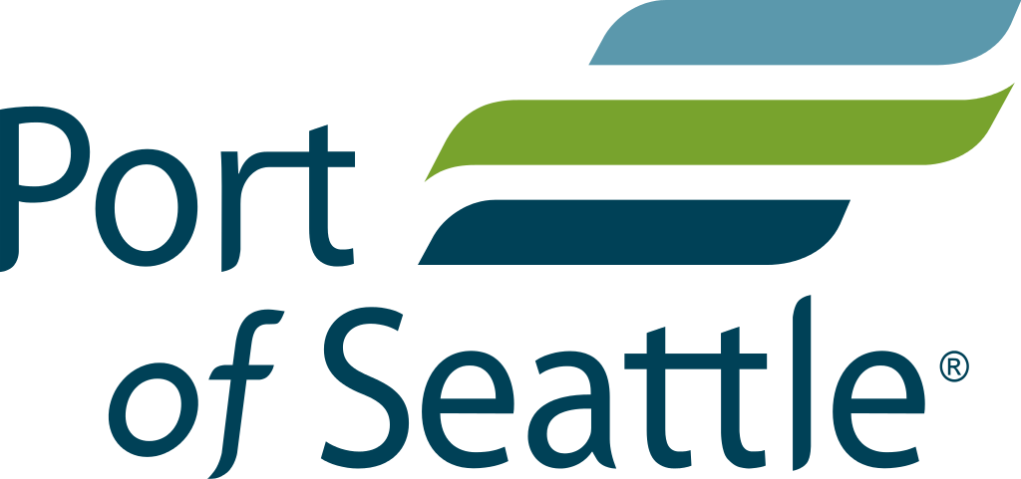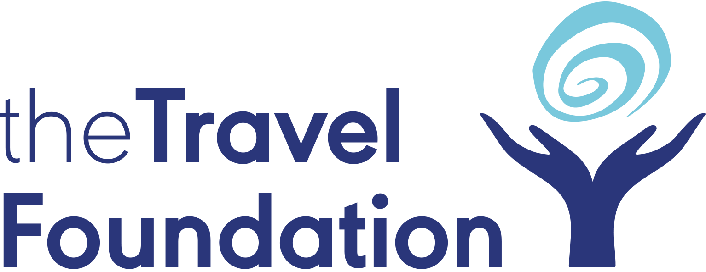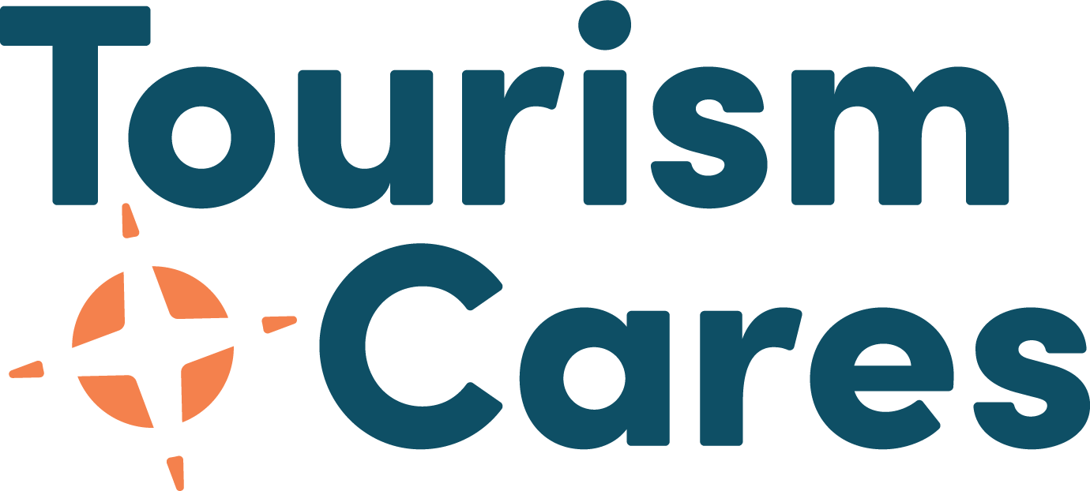
2023

Table of Contents
How to use the Workbook 3
Section 1: Introduction 3
Section 2: Why Take Action Now 4
Reflection Questions 4
Section 3: Towards Sustainable & Inclusive Tourism in Washington 4
Reflection Questions 4
Worksheet: Diversity, Equity, Inclusion and Accessibility 5
Section 4: Your Organization and Community’s Context 6
Reflection Questions 6
Worksheet: Ideal Outcomes 7
Worksheet: Map Potential Partners & Collaborators 8
Section 5: Understanding, Measuring and Managing Tourism’s Impacts 10
Reflection Questions 10
Worksheet: Impact Management Part 1 11
Worksheet: Impact Management Part 2 12
Section 6: Product Development 13
Reflection Questions 13
Section 7: Responsible Marketing & Communications Strategies 13
Reflection Questions 13
Worksheet: New Product & Marketing Strategies Using the Destination Stewardship Lenses 15
Section 8: Supporting Businesses to Adapt & Build Resilience 16
Reflection Questions 16
Worksheet: Identifying Business’ Needs and Support Strategies 17
Section 9: Creating and Action Plan 18
Reflection Questions 18
Worksheet: Pulling it all together into an action plan 19
Checklist to ensure your plan is deliverable 20

How to use the Workbook
- Make a copy in your own Google Drive [Click File > Make a Copy] or download to Word {Click File > Download > Microsoft Word]
- Use in the way that works best for you. For example, you can type answers into the doc, copy tables into Excel or Google Sheets, copy sections into other tools you are already using.
- The sections of the workbook are labeled with the same numbered sections of the Responsible Travel Handbook for Washington Tourism Organizations. Feel free to jump to whichever section you are interested in working on most. (Use the table of contents to click through to a section of your choice).

Section 1: Introduction
This companion workbook to the Responsible Travel Handbook for Washington Tourism Organizations includes reflection questions and worksheets from each section of the handbook to support each reader on their journey in sustainable tourism and responsible outdoor recreation, including improving diversity, equity inclusion, and accessibility. Worksheets are designed to help you think through concepts from your organization's perspective, and to support you to develop new actions to implement or to create a new action plan for your organization.

Section 2: Why Take Action Now

Reflection Questions
- Did you learn anything new while reading this section?
- Were there perspectives that you hadn’t thought of that you are interested in learning more about?
- Are you aware of existing initiatives in your community focused on areas of environmental protection including reducing waste, decarbonization, protecting wildlife, conserving water, etc.?
- Are you aware of existing initiatives by businesses in your community to become more inclusive and accessible?
- Does your organization have any goals in place relating to the themes of the Sustainable Development Goals (SDGs) e.g., environmental protection, poverty, inequality etc.?

Section 3: Towards Sustainable & Inclusive Tourism in Washington

Reflection Questions

- What are the main challenges related to tourism in your community or organization?
- What are the biggest future threats to tourism in your community or to your organization?
- Do you have any relationships with or tourism initiatives in place with Indigenous communities?
- What is the status of inclusivity in your organization or destination? And where would you like to get to?
- What organizations would you like to reach out to and support or engage for advice?

Building on the above questions, the following worksheet walks through each of the topics in the handbook to help you develop or enhance your strategy for improving diversity, equity, inclusion, and accessibility.

Worksheet: Diversity, Equity, Inclusion and Accessibility

Areas of Action | Ideal Situation  Where would you like to get to in this area? | Current Situation  What are things like now in this area? | Specific Actions  What are you going to do?
Organization’s Education & Awareness

Seeking out Advice
Reviewing practices
Engaging in training
Policy and action plan
Representation and inclusivity in employment
Representation and inclusivity in products & experiences offered
Representation and inclusivity in marketing and communications
Other

Section 4: Your Organization and Community’s Context

Reflection Questions

- Do you have a tourism plan or strategy document? If so, how up to date is it?
- Could you make any immediate changes within your organization’s structure and operations to improve sustainability?
- Do you have policies in place to improve diversity, equity, inclusion and accessibility? Can you think of any changes you could make in your organization
- that would widen opportunities for marginalized or
- underrepresented groups?
- What other groups or organizations in your community could you engage with to strengthen existing plans/ develop a new plan?
- What are your long-term goals or ideal outcomes that you would like to work
- towards, building on the immediate actions you are considering?

In the worksheets that follow, you will outline your ideal outcomes and start thinking about how you want to achieve them. You’ll also map potential collaborators and partners to work together toward common goals.

Before embarking on an action plan for sustainability, it is useful to reflect on what you think the main goals and outcomes of tourism should be in your community. It is worth opening up this discussion to colleagues in your organization, or those that you work closely with such as your board if you have one, so that you are including a wider range of perspectives. You could discuss it during a team meeting, planned brainstorming session, working lunch or in informal one-to-one or group chats with colleagues. To frame the discussions, it might be useful to think about what tourism would look like in your destination in a perfect world, i.e. with no barriers. It is also important to take some time to map out potential collaborators and partners, identifying those entities or individuals whose buy-in and engagement will be vital for creating and implementing your plan, or who will play an important role in supporting it. Consider how you can collaborate with and proactively engage others in your community to achieve your sustainability goals - within your local area as well as across the sector in which you operate. You can use the table below to help you map out key individuals, businesses, communities, and organizations to connect and work with.

Worksheet: Ideal Outcomes

Goals and Ideal Outcomes | Current Situation | Gap | Areas of Influence | Barriers
What are the main goals that tourism should be contributing to in your community? E.g. it should be improving the livelihoods of residents; it should be boosting conservation etc. | What's being done already in this area? Write down policies, plans, initiatives, your organization is already undertaking | Where are the main gaps? Write down key/popular ideas from 'ideal scenarios' that are not covered in current practices or strategies. | What is in my organization's control? Write down aspects within this goal that you can lead on, advocate for, or note where you need to identify partners or collaborators. | What do you think are the main barriers for implementing ideas from 'ideal scenarios' section?
E.g. Environmental: Tourism contributes to conservation, restoration, and minimizes negative impacts such as waste, etc.
E.g. Socio-economic: Tourism strengthens local supply chains, entrepreneurship opportunities, creates job opportunities, and supports decent working conditions, maintains access to amenities and services, etc.
E.g. Cultural: Tourism celebrates cultural diversity, supports community priorities, etc.

Worksheet: Map Potential Partners & Collaborators

Potential Partners & Collaborators  WHO could we collaborate with? | WHAT could we do  together?
Local (e.g., Tribal governments, other local government agencies, businesses, local associations, resident & community groups, political representatives, government agencies, NGOs, social enterprises, educational institutions, chambers of commerce)
Regional / national (e.g., DMOs and other tourism organizations, trade association, funders)
Across the sector (e.g., professional organizations such as specialists in DEIA, communities of other destinations and tourism businesses across geographies)

Reference Table: Rights & Title Holders, Stakeholders and Partners
Definitions
Sovereign government and rights holder | Indigenous peoples are sovereign governments and rights & title holders, and not referred to as "stakeholders". Indigenous peoples have constitutionally protected rights and are not solely stakeholders to engage.
Public Sector | Governors, Advisors, Civil Servants, Civil Departments, Elected Representatives, Courts, Political Parties, Local Government/Councils, Military, Commissions, International Bodies (ie: UNWTO)
Private Sector | Corporations, Businesses, Business Associations, Professional Organizations, Business Leaders, Financial Institutions
Civil Society | Media, Churches/Religious Institutions, Schools/Universities, Social Movements/Advocacy Groups, Community Groups, Trade Unions, National NGO/nonprofits, International NGO/nonprofits
Key Stakeholder or Partner | Those who can significantly influence the success of the project
Primary Stakeholder or Partner | Are those directly/ultimately affected, either positively, (beneficiaries) or negatively.
Secondary Stakeholder or Partner | Other individuals, groups or institutions with a stake, interest or intermediary role in the project
Importance | Priority given to satisfying the needs and interests of this particular topic
Influence | Reflects the power of a stakeholder to affect the project
Underrepresented Communities/ Typically Marginalized People and/or Groups | These community members tend to be left out of planning processes
Racialized Communities (BIPOC - Black, Indigenous, People of Color) | Research the demographics of your destination to better understand who may not be represented in the planning process
Persons with disabilities | Persons with disabilities include people with mental, physical, and sight impairments
Generational gaps | Consider people who are either 55+ or youth under 18 or under 10
Socio economic status | Consider people who are single parents, under the poverty line, how they contribute to travel economy
LGBTQ+ Status | Consider any bias or barriers for people who identify as LGBTQ+
Gender Status | Consider women's groups, mothers, single mothers, women entrepreneurs, people who may be transitioning

Section 5: Understanding, Measuring and Managing Tourism’s Impacts

Reflection Questions
- What insights do you already have on the environmental, social and cultural impacts of tourism in your destination?
- How were these affected by the pandemic?
- How might they be impacted by climate change and extreme weather events?
- What existing data is available to better understand these impacts?
- What are the main negative visitor impacts in your community? Do you have any strategies to minimize these impacts?
- Do you have tools in place for tracking the flow of visitors in your community?

In the Impact Management worksheets that follow, you will build on the first exercise where you captured the vision and overall goals for the future of tourism in your community or your organization. It is necessary to think about what are the main positive and negative impacts of and threats to tourism, now and how they might change in future. This will help you to think of ideas and solutions for enhancing the positive and minimizing or mitigating the negative impacts & risks or threats, in order to build the resilience of your destination in the long term.

Worksheet: Impact Management Part 1
Impact (Positive to Manage For) | Impact (Negative to Mitigate) | External Threats (to Prepare for & Adapt to) | Data sources (existing or needed)
Environmental
E.g. Financing conservation  Promoting conservation | E.g. Cost of managing and maintaining habitats  Pollution and degradation | E.g. Climate Change - related weather events such as wildfire, smoke, flooding | E.g. Carrying capacity, Visitor data to sites  Animal welfare and Biodiversity, Tourism energy, water, waste consumption and sustainable practices, Transport usage
Socio-economic
E.g. Employment, small biz development, revenue, Investment in amenities and infrastructure | E.g. Rising home/ land prices  Infrastructure upgrade costs  Loss of access | E.g. Lack of workforce | E.g. Economic data (employment, revenues, % local procurement), Tourism spend surveys  Resident surveys (wellbeing and tourism satisfaction), Crime, accident statistics relating to tourism
Cultural
E.g. Financing conservation of cultural heritage | E.g. Inappropriate behavior | E.g. Community & cultural conflicts | E.g. Visitor data to cultural sites and/or activities, Carrying capacity

Worksheet: Impact Management Part 2
Impacts & Threats identified in previous exercise | Solution or Action to manage this impact (to enhance positive impacts and mitigate negative ones) | Resources required to manage impacts (Financial, human, including other partners outside your organization) | Priority Level  Low / med / high
Environmental
Socio-economic
Cultural

Section 6: Product Development

Reflection Questions
- Can you make any immediate tweaks to your products that would increase the benefits for local people and/ or the environment?
- What longer-term changes can you make to the way you design and package tourism products and experiences in your community?
- Do any of your existing products tap into the demand for local and sustainable products and experiences?
- Can you think of any new products that you could develop that would align to this demand?
- Are you defaulting to “bucket list” marketing?

Section 7: Responsible Marketing & Communications Strategies

Reflection Questions
- What is the visitor profile of the biggest market segment for your business or destination?
- Would different types of visitors provide more value?
- Could you make any changes to your products to attract different types of visitors?
- Do you have strategies in place that target specific visitor groups who are more environmentally conscious?
- Can you think of any small tweaks you can make to your marketing and communications that would boost the sustainability and resilience of your community?
- Do you have marketing strategies in place that boost the profile of sustainable
- products and experiences? E.g., cycling tours, local-food products, experiences
- that support local businesses or underrepresented groups, or social enterprises?

In the worksheets that follow, consider existing experiences and marketing strategies & tactics, and how you might adjust them based on new goals around reducing impacts and improving benefits. Using the lenses of DEIA, Climate Action, and general Destination Stewardship principles. Think also about new products or experiences you may wish to develop and market going forward.

Worksheet: New Product & Marketing Strategies Using the Destination Stewardship Lenses

New or Existing | Product/ Experience | Marketing & Communications | Diversity, Equity, Inclusion, Accessibility | Climate Action | (Other) Destination Stewardship - environmental, social, etc.
Existing | E.g. Wine Tour | E.g. Promoting experiences that are low-impact, high-benefit | E.g. Marketed to, or packages for diverse populations to participate | E.g. Using e-bikes or shared shuttle (or EV shuttle) | E.g. No single-use plastics (like water bottles)
New

Section 8: Supporting Businesses to Adapt & Build Resilience

Reflection Questions
- What existing financial support mechanisms are available? Are they being accessed by businesses?
- What new knowledge/skills might be required to improve the sustainability of tourism in your community or to respond to future challenges?
- What skills gaps are there?
- Where are the labor shortages?
- How can these needs/gaps best be addressed?

Use the worksheet that follows to think about what existing supports may be available to you or to businesses you work with (if you are an umbrella organization like a destination marketing & management organization or chamber of commerce), and what gaps there are in terms of what is available and accessible by businesses compared to what they need. Then think about how you might lead or partner on providing support in the needed areas.

Worksheet: Identifying Business’ Needs and Support Strategies

Types of Support | Existing (provided by your organization or available from others) | Needs/Gaps | Potential new initiatives
Financial (grants, etc.)
Technical Assistance (advising/consulting, training, audits, etc.)
Marketing (cooperative, packaging, etc.)

Section 9: Creating and Action Plan

Reflection Questions
- How will you define success?
- Do your chosen metrics address what is important?
- How much emphasis have you placed on effort vs effectiveness or impact?
- Have you planned for baseline data collection as well as ongoing
- monitoring and measuring?
- Can you easily adapt?

This section is where we pull things together, decide on our plan's goals, the actions we want to take to make a positive impact, and reduce negative impacts as well as mitigate risks, and lay out how we will measure progress and success. Use the worksheet that follows to lay out the ideal outcomes you came up with earlier, and refine your goals. Then list actions you (or you and partners) will take to achieve those goals. Then think about both how you will track progress on the actions, as well as the impact they are having. These are two types of indicators - refer back to the handbook for more guidance. Identify whether you will lead or partner on the initiative and who/which organization might support you on it. Finally, think about what is feasible both from a timeline and budget perspective. This will help you ensure your plan can be implemented.

Worksheet: Pulling it all together into an action plan

Impact Area | Goal or Ideal Outcome | Actions | Indicators of Effort  (How will you measure what you will do?) | Indicators of Effect or Impact  (How will you measure the impact?) | Lead Responsible and Support (Internal and/or external) | Timeline (near, mid, long term)  E.g. Yr 1, Yr 2-3, Yr 5 | Source of funding  (internal or external)
Environmental | E.g. Tourism contributes to conservation and restoration | E.g. Set up a fund for businesses and visitors to contribute to | E.g. Amount $ Contributed | E.g. Conservation Outcomes (results from funds invested) | E.g, Local partner organization | E.g, Yr 2 | E.g, Internal budget
Socio-economic | E.g. Tourism businesses are able to attract and retain sufficient workforce | E.g. Provide workforce development resources to businesses | E.g. New resources identified and provided | E.g. New employees placed; worker satisfaction increase | E.g, Local partner organization | E.g, Yr 1 | E.g., gov grant
Cultural | E.g. Tourism celebrates our diverse cultures | E.g. Inventory all cultural communities and businesses and potential products | E.g. Cultural content published | E.g. # new bookings to diverse cultural activities | Eg., Consultant | E.g. Yr 1 | E.g., internal budget

Checklist to ensure your plan is deliverable
- Have residents, diverse community groups, important partners, and Tribal governments, and their priorities and perspectives been taken into account in developing the plan?
- Are roles and responsibilities for delivering and monitoring the plan clearly outlined, recognizing the contributions that the public and private sector will
- Make?
- Is there sufficient capacity to deliver the plan– both in terms of staff resources and staff skill sets?
- Is there sufficient budget and/or access to finance to deliver the plan?
- Is the timeframe appropriate and are there key milestones to inform measuring progress?
- Are there ongoing communication mechanisms in place to ensure cross-sector alignment and collaboration (across the public, private and third sectors) to deliver the plan?
- Is the plan aligned with other community level strategies?

Congratulations on taking this step to turn your goals into action for a better future of tourism!

